Instructions for using the sales management system

Furniture System

* This is the beginning of the system:

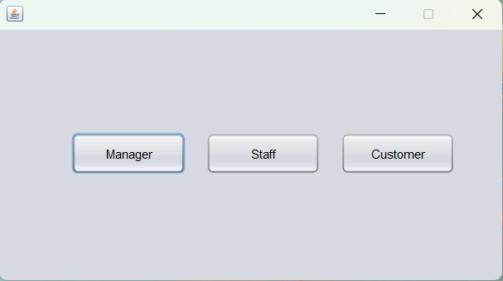

- Manager: The management section is for the manager of the store.

- Staff: The management section for the client's employees.

- Customer: Interface for customers.

**I.Manager:** Management section for store management.



Manager of store

Clicking on "Manager" will bring up the login form for manager.

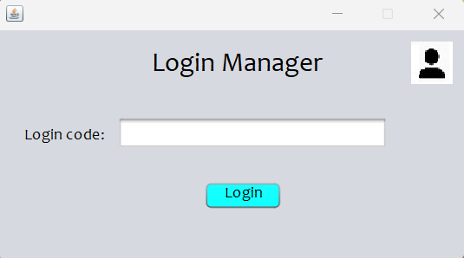

-Enter the Manager code and click LOGIN.

-Successful login will go to the store manager's management interface.

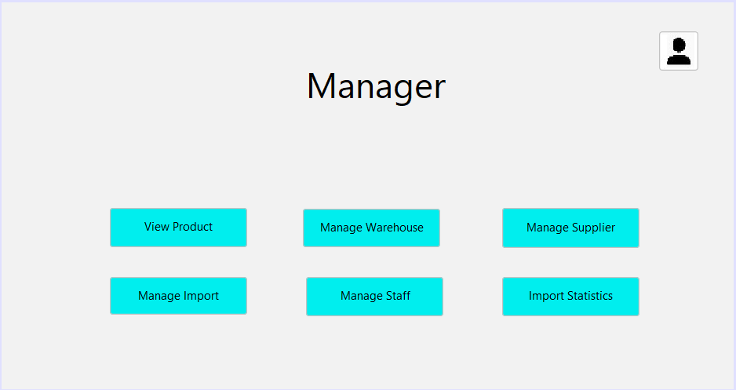

**1.View Product**



- This is the product management interface. You can click on the table below to display product images. Click on the "SEARCH ID" box to search for products by name and price.

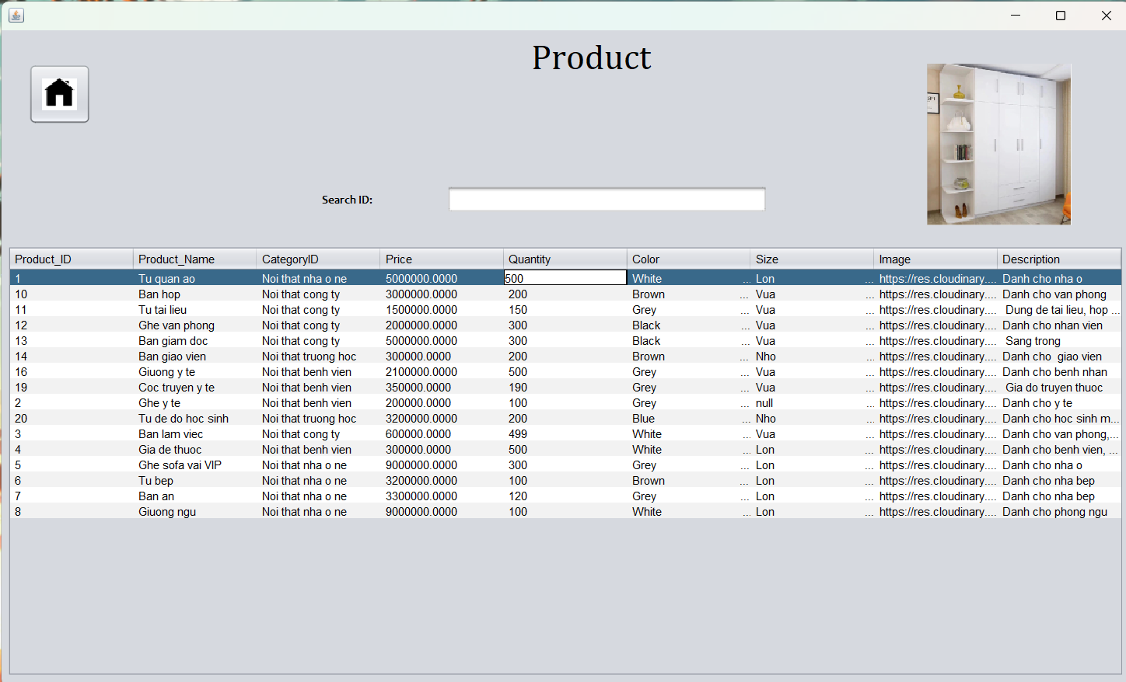

-Search by product name:

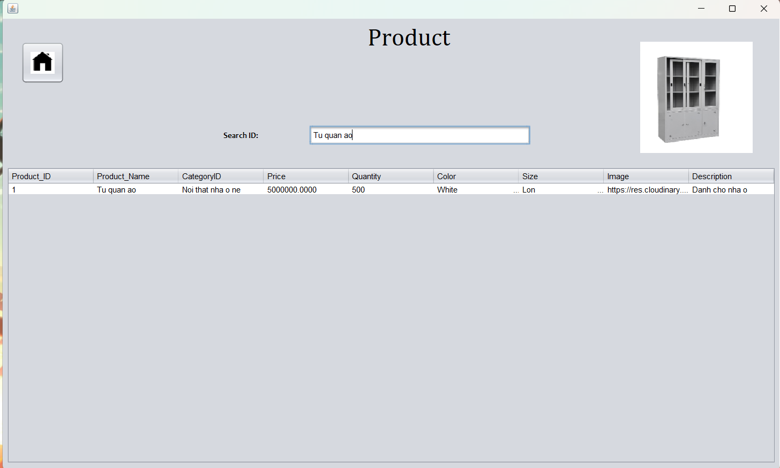

-Search by product price:

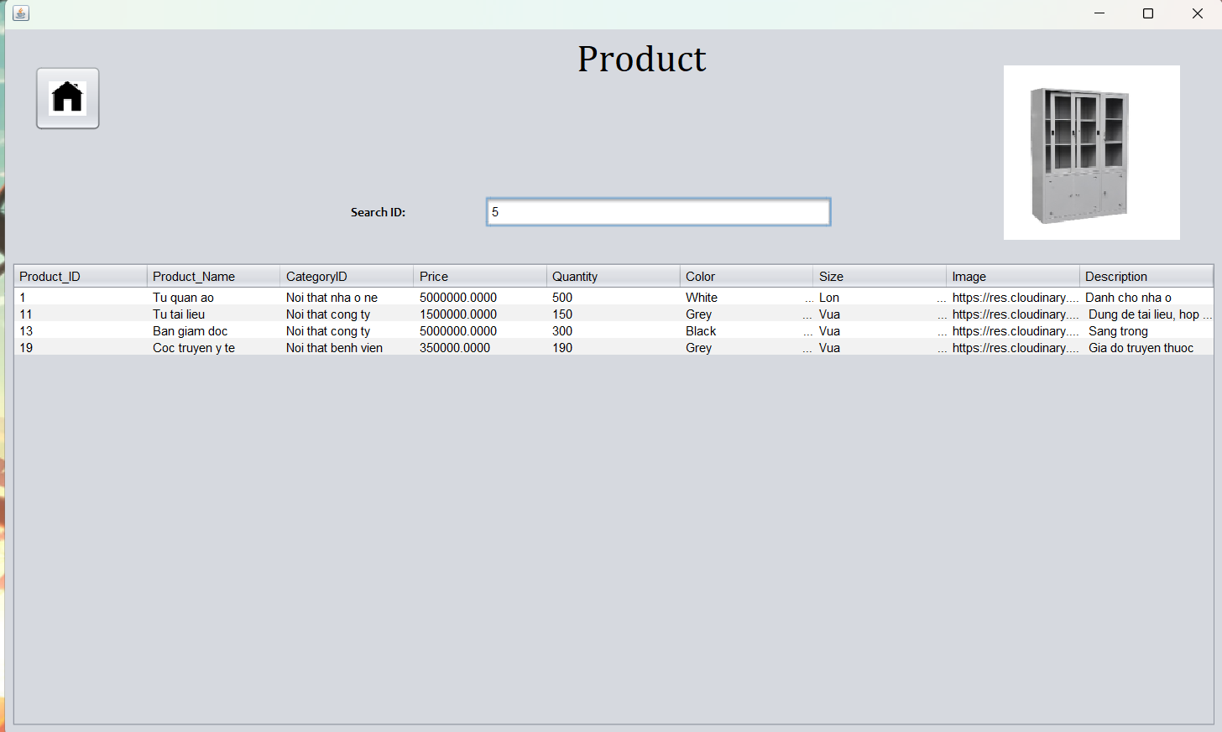

-Click on the house icon to return to the main interface.



1. **Manage Warehouse**

-Click Manage Warehouse to manage the warehouse.



- In this section, managers will be viewing, adding, editing, deleting repositories.

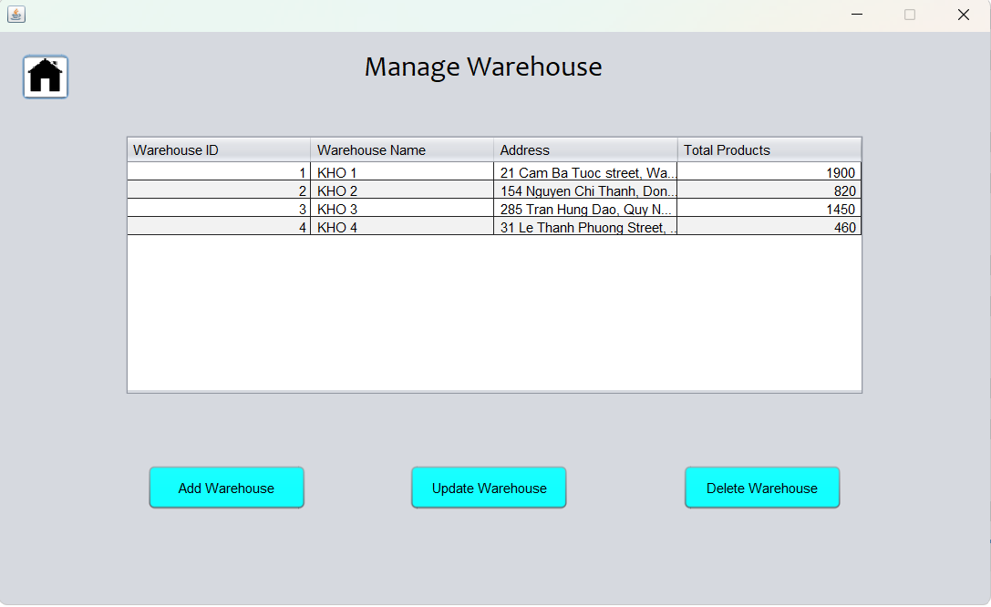

-Click on "ADD WAREHOUSE" to add warehouse.



-When clicked, it will go to the add product page. Fill in the form of the form and click "ADD". The system will notify you if you add successfully.

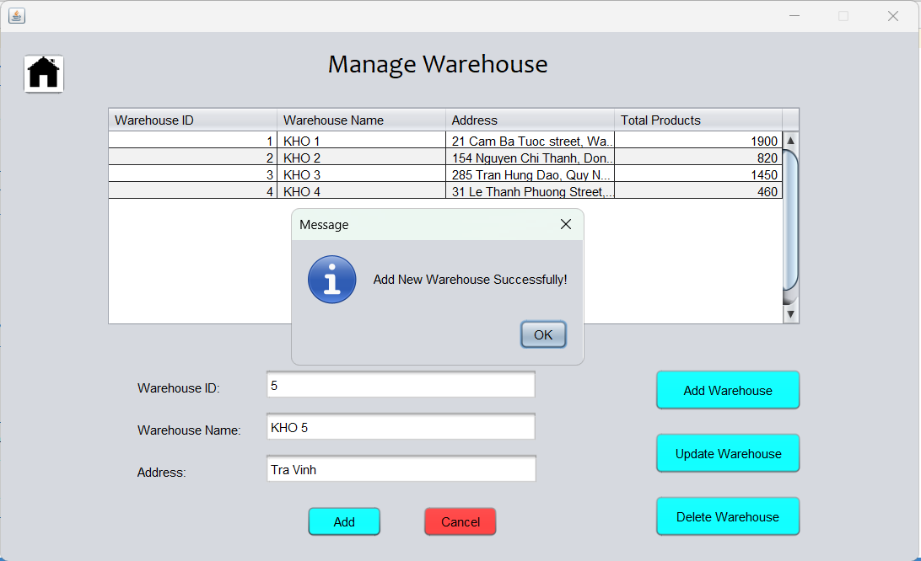

-Click OK and click Cancel to return to the WAREHOUSE interface.



-Click on "UPDATE WAREHOUSE" to correct warehouse information. The system will go to the warehouse update page.

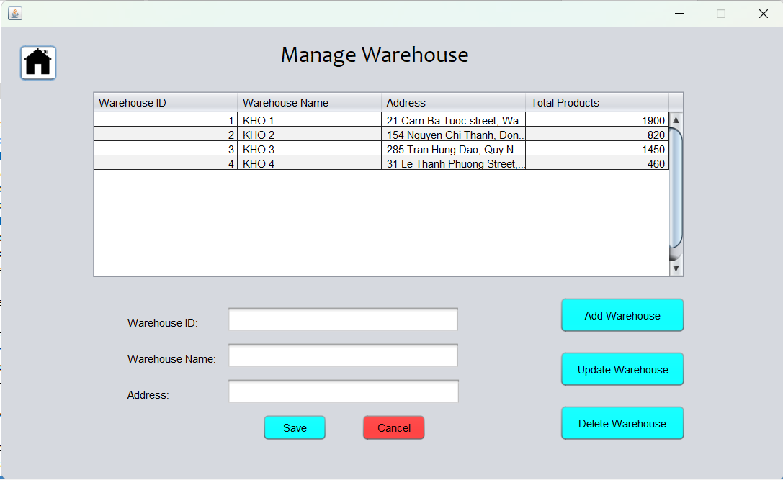

-Click on the repository to be repaired, the repository information will be displayed on the frames. Enter the information to be edited and click the "SAVE" button to correct the repository information. The system will display a notification if you successfully edit.

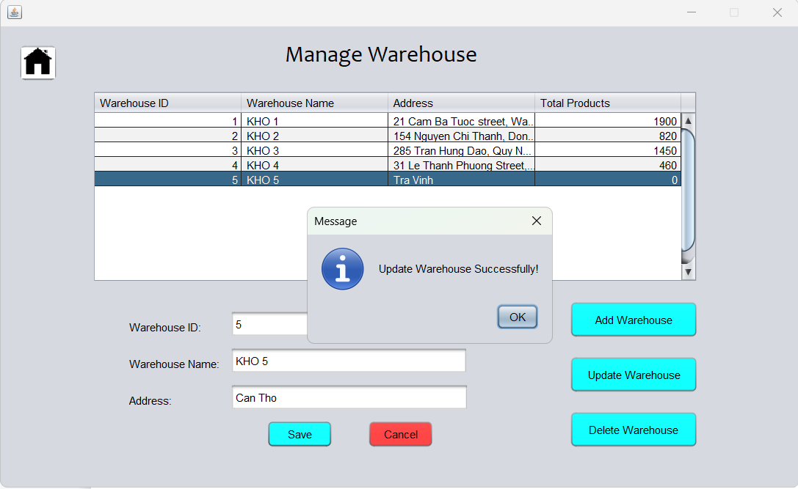

-Click CANCEL to return to the WAREHOUSE interface.



-Click on DELETE WAREHOUSE to redirect the system to the delete warehouse page.

The system will delete the warehouse by ID, so we need to enter the ID into the WarehouseID box or we can directly click on the warehouse we want to delete on the information panel above.

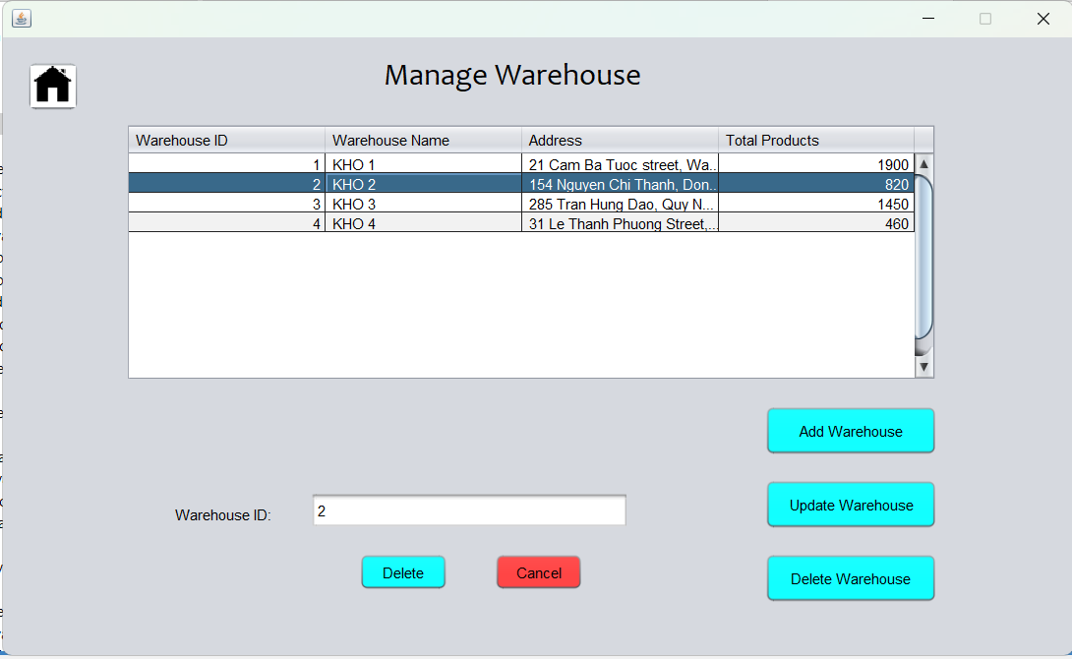

-After having the repository ID, click on the Delete box to delete the repository. The system will display a message of successful deletion of the repository.

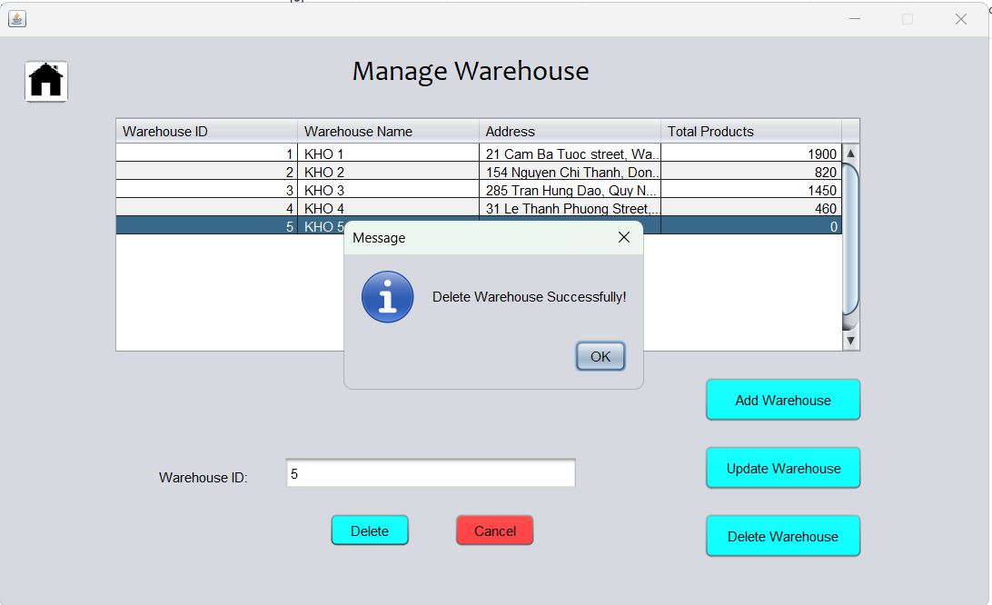

Note: You can select the button here without having to go back to the main interface of the Manage Warehouse.

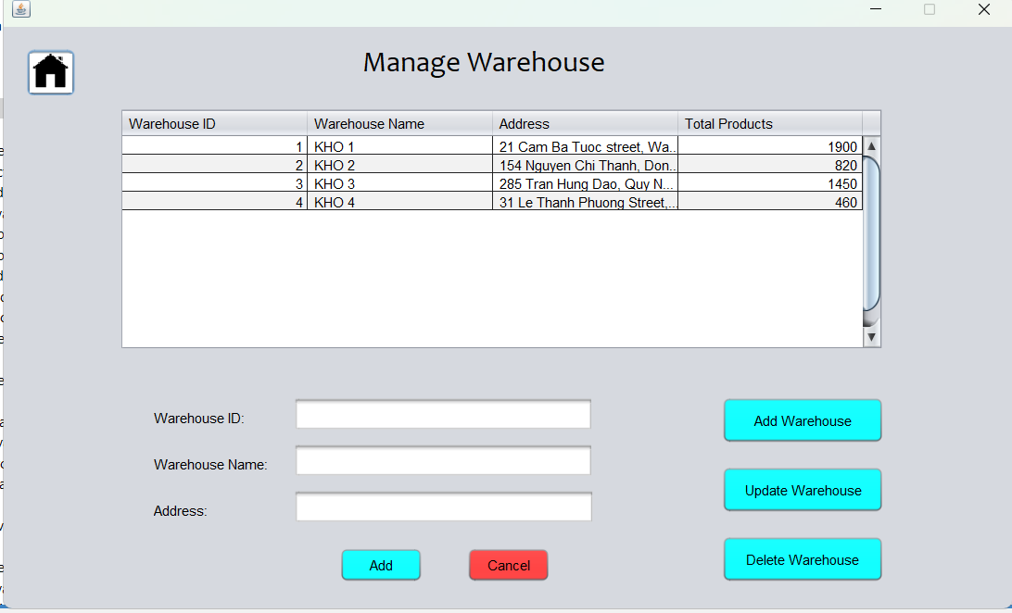

-Click the home button to return to the Manage interface.



**3.Manage Supplier.**

Click on "MANAGE SUPPLIER" to take you to the Supplier management interface.



-Click on "ADD SUPPLIER" to add supplier.

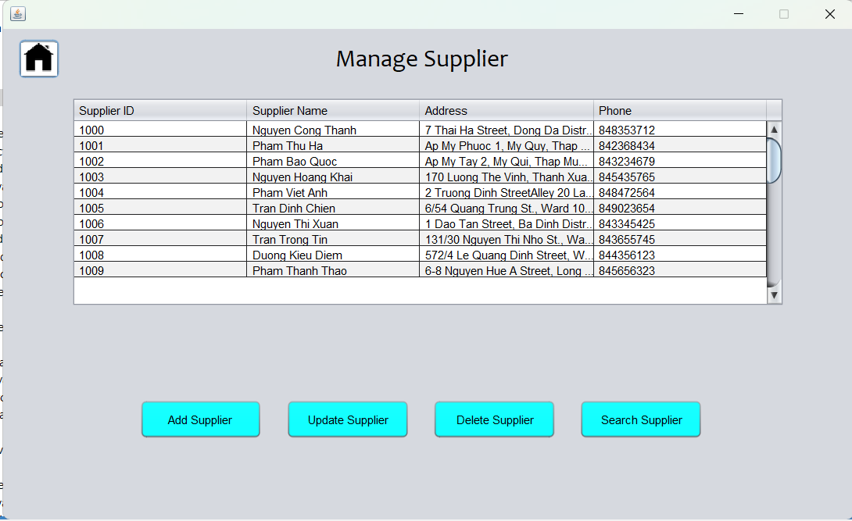

-When clicked, it will go to the add product page. Fill in the information in the field.

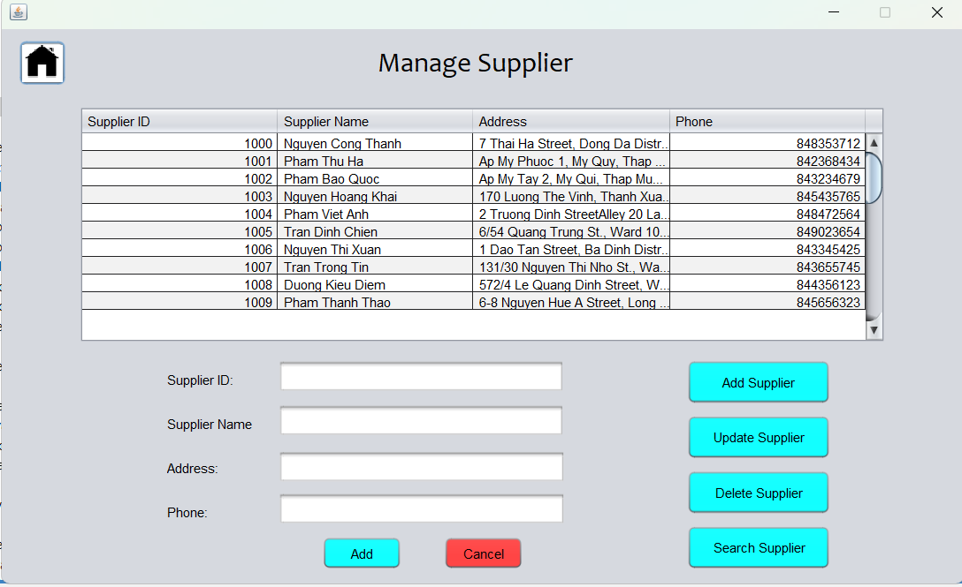

-Click "ADD" to add a provider.

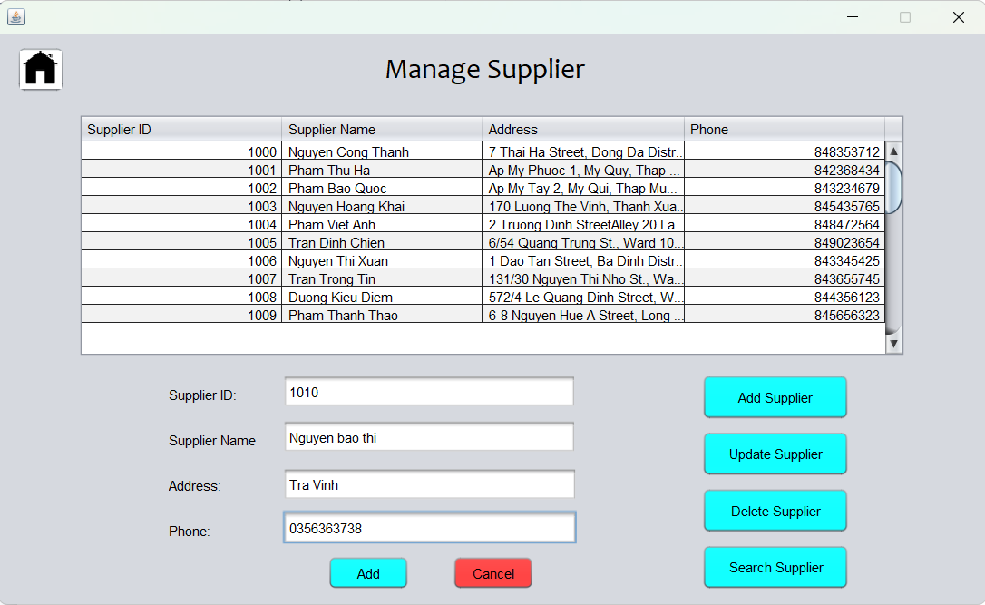

-The system will notify if you add successfully.

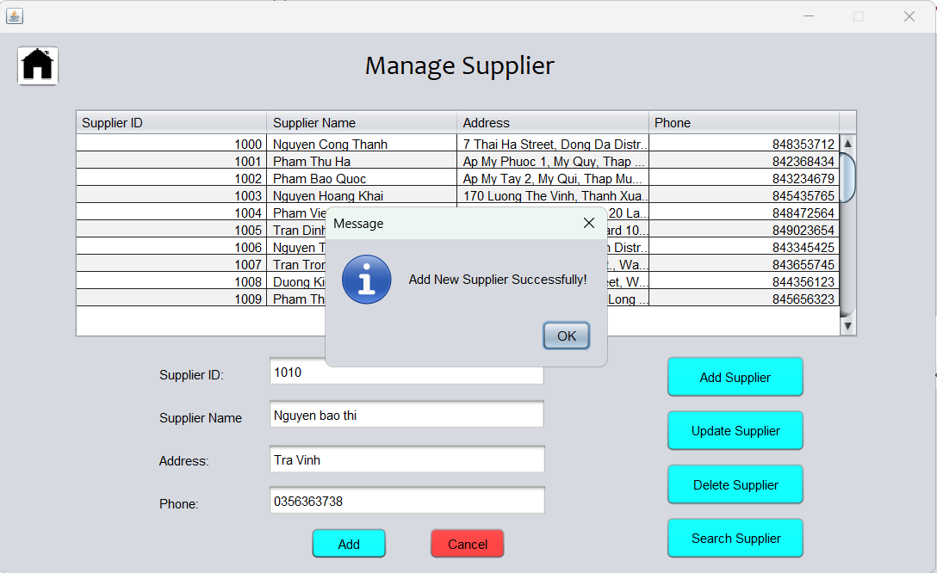

-Click CANCEL to return to the MANAGE SUPPLIER interface.



-Click on "UPDATE SUPPLIER" to correct the warehouse information. The system will go to the MANAGE SUPPLIER page.



-Click on the information to be corrected, the information will be displayed on the frames. Enter the information to be edited and click the "SAVE" button to correct the supplier information. The system will display a notification if you successfully edit.

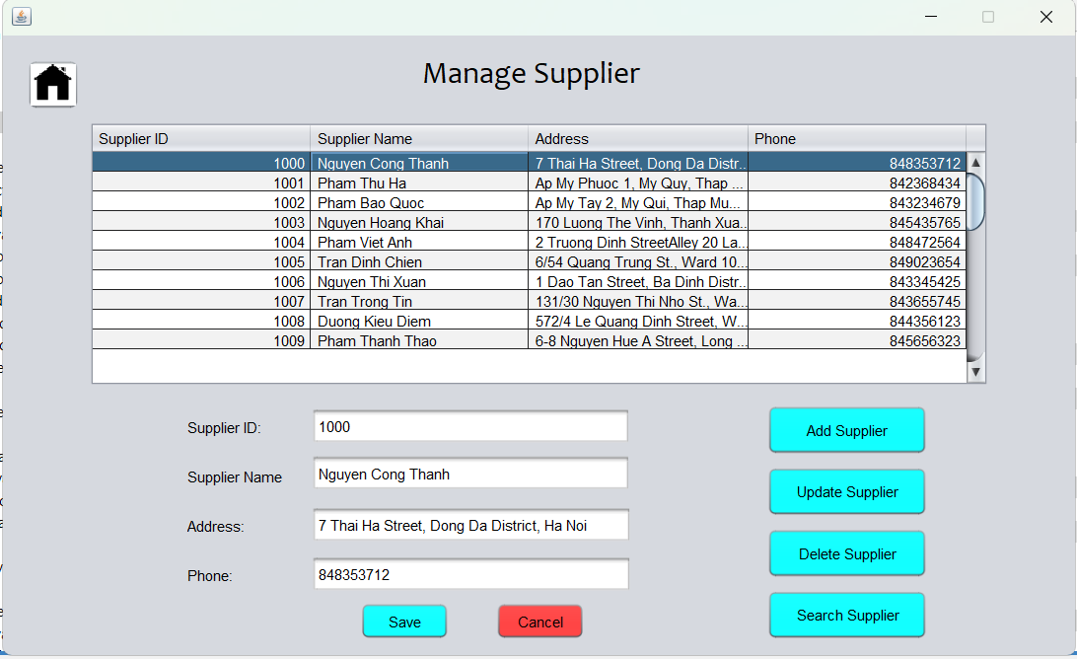

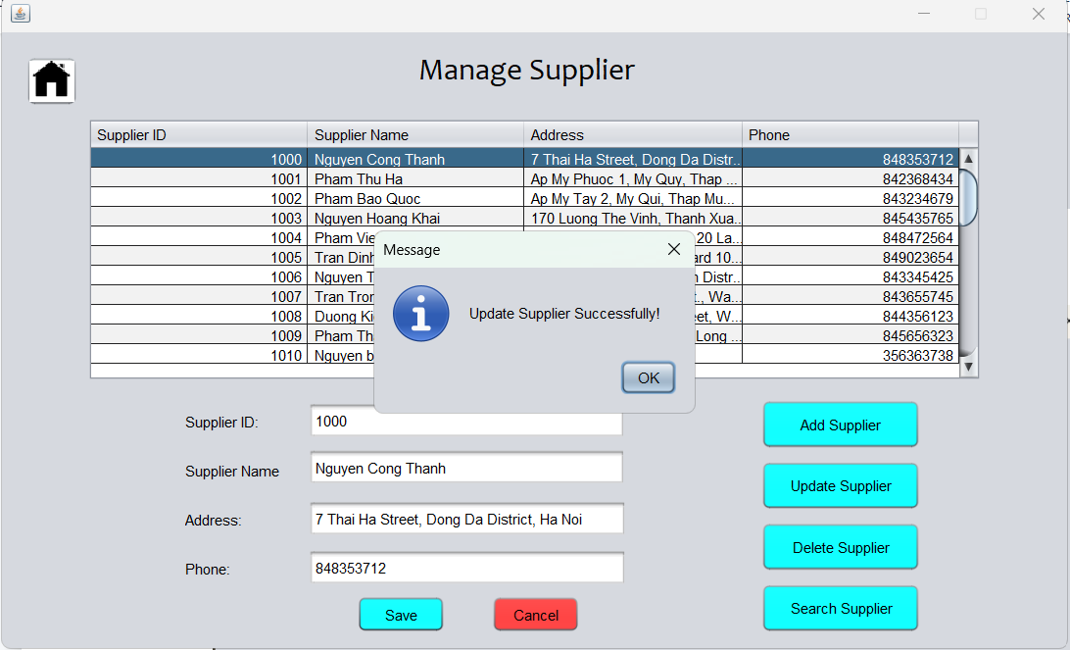

- Click CANCEL to return to the SUPPLIER interface.

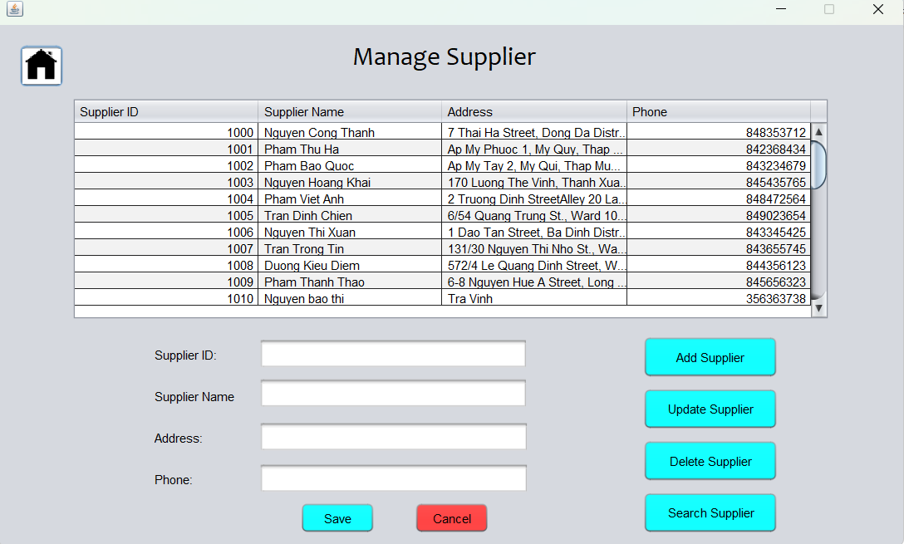

- Click on DELETE SUPPLIER to redirect the system to the delete repository page.



-The system will delete the warehouse by ID, so we need to enter the ID into the SupplierID box or we can click directly on the supplier you want to delete on the information panel above.

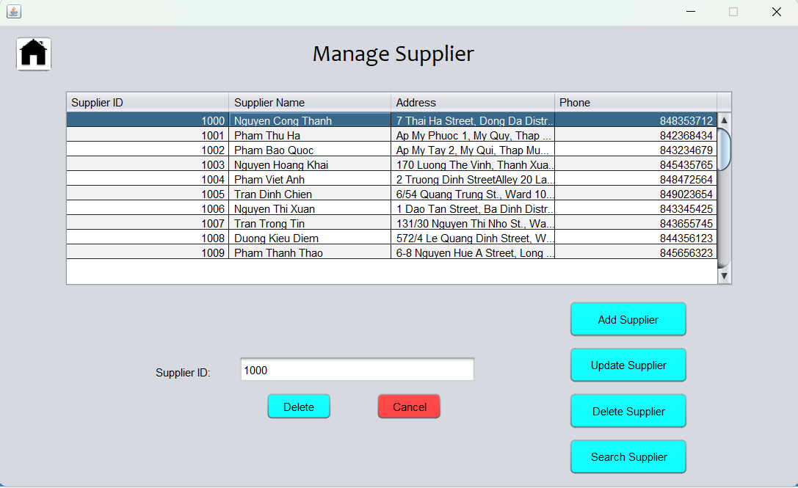

- Click OK to turn off notifications.

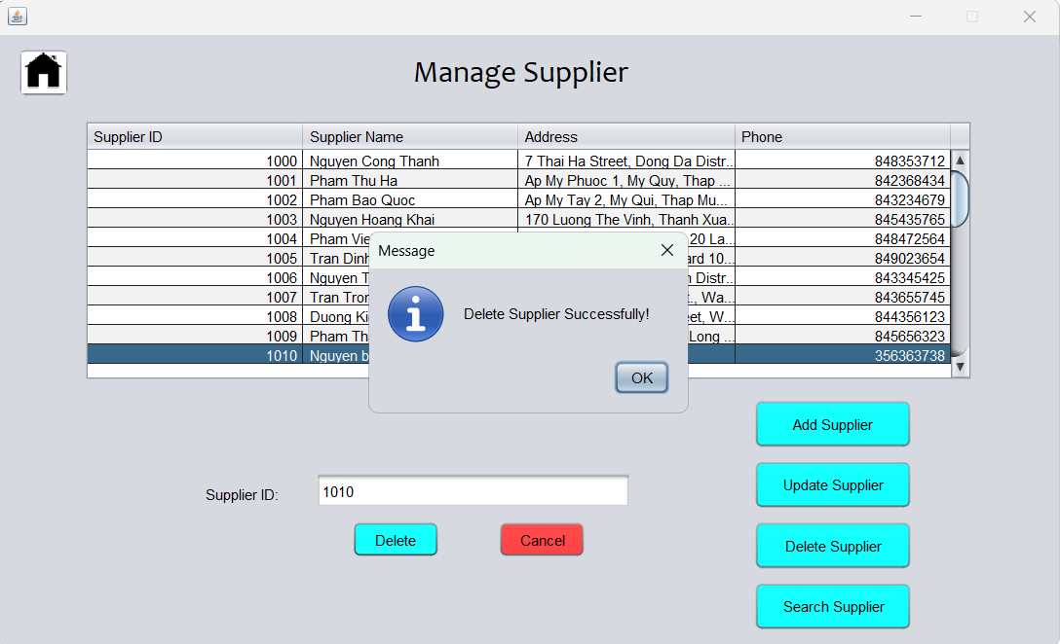

- Click CANCEL to return to the SUPPLIER interface.



- Click on SEARCH SUPPLIER to redirect the system to the supplier search page.



-Fill in the information you need to find in the search box. We can find through ID, Name, Address, Phone.

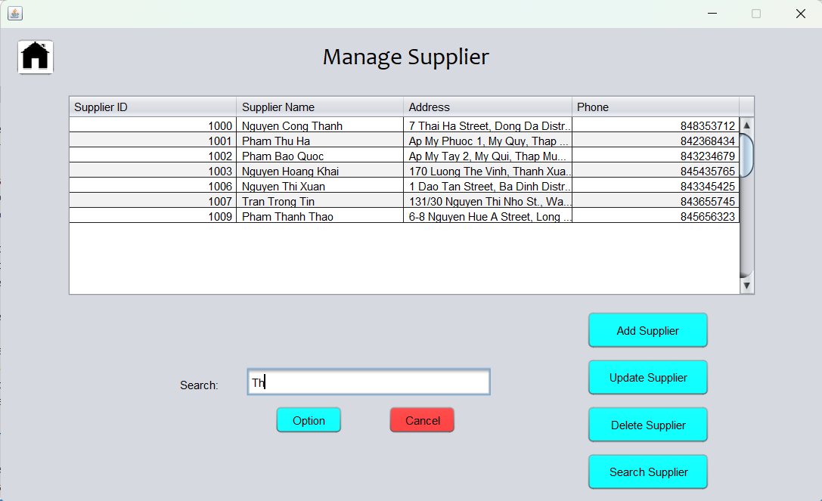

-Click CANCEL to return to the SUPPLIER interface.



-Click the home button to return to the Manage interface.





*Note: We can add, edit, delete, search for information directly with the above buttons without having to go back to the Manage Supplier page.



1. **Manage Import**

-Click "MANAGE IMPORT" to navigate to the manage Import Products page



-Click "ADD IMPORT" and the system will move to the add import product page.

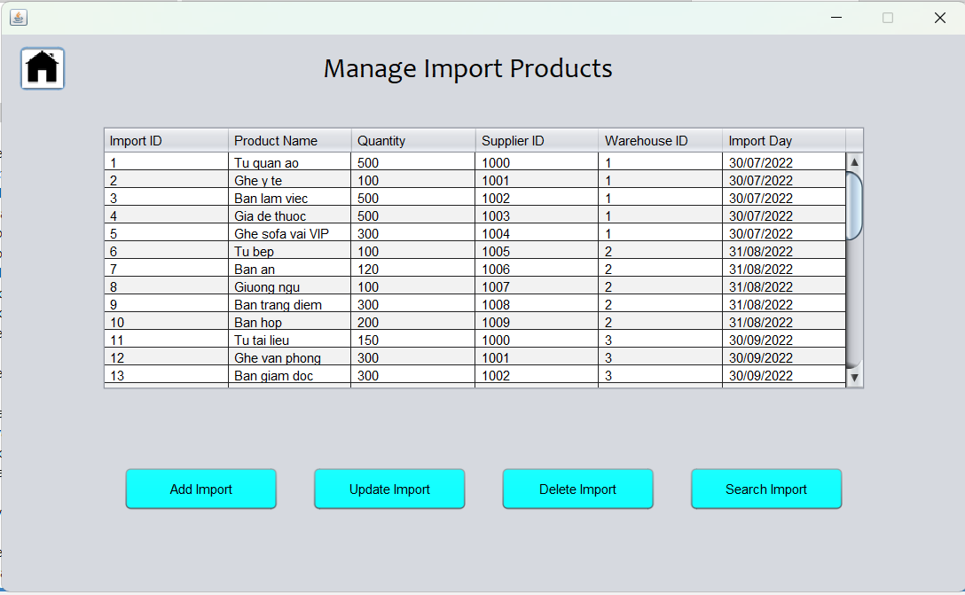

-Fill in the necessary information in the boxes and click "ADD".

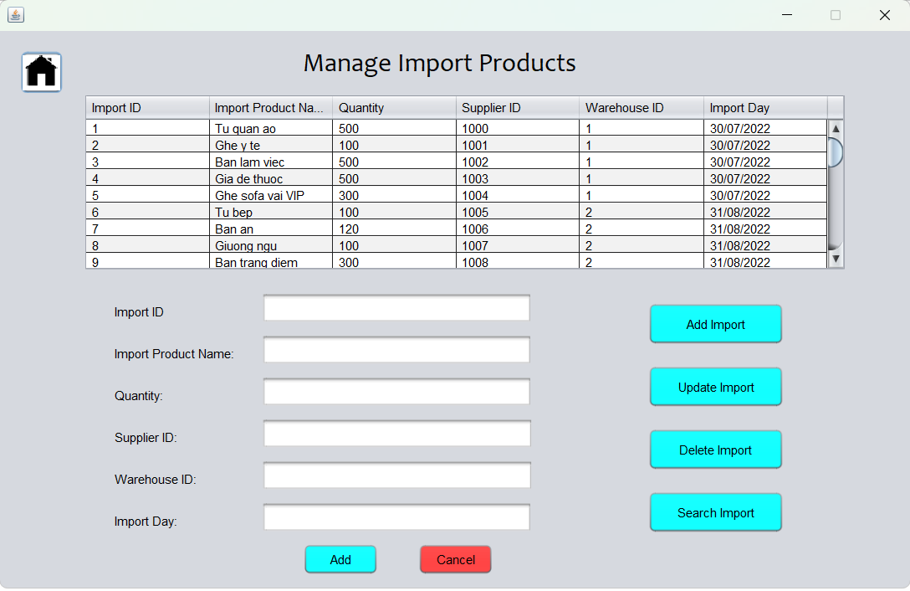

-The system will display an additional success message.

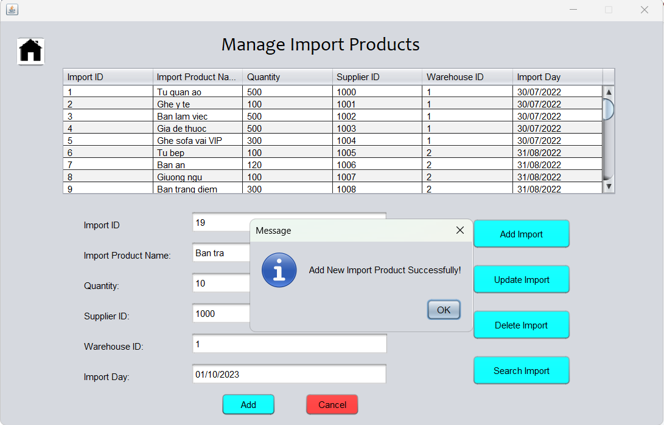

-Click Cancel to return to the Manage Import Product page.



-Click Update Import to edit the import product.



-Select the row to edit the information, the information will be transmitted down according to the correct position of the boxes. Edit the information you want to edit. Click on "Save".

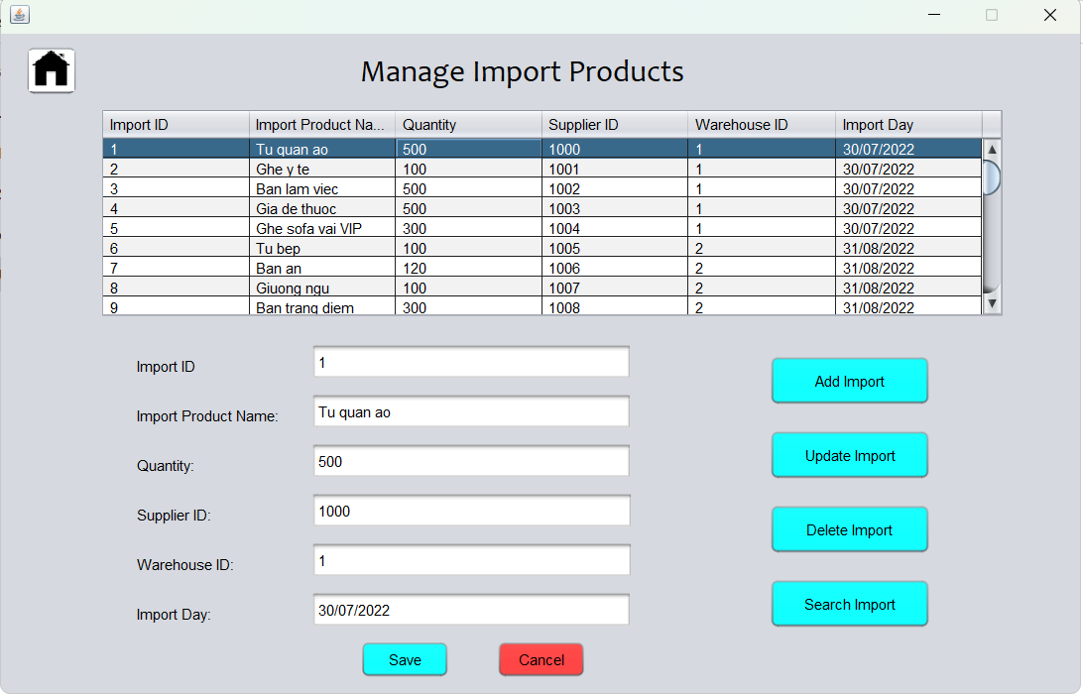

-The system will display a successful edit message. Click OK to turn off notifications.

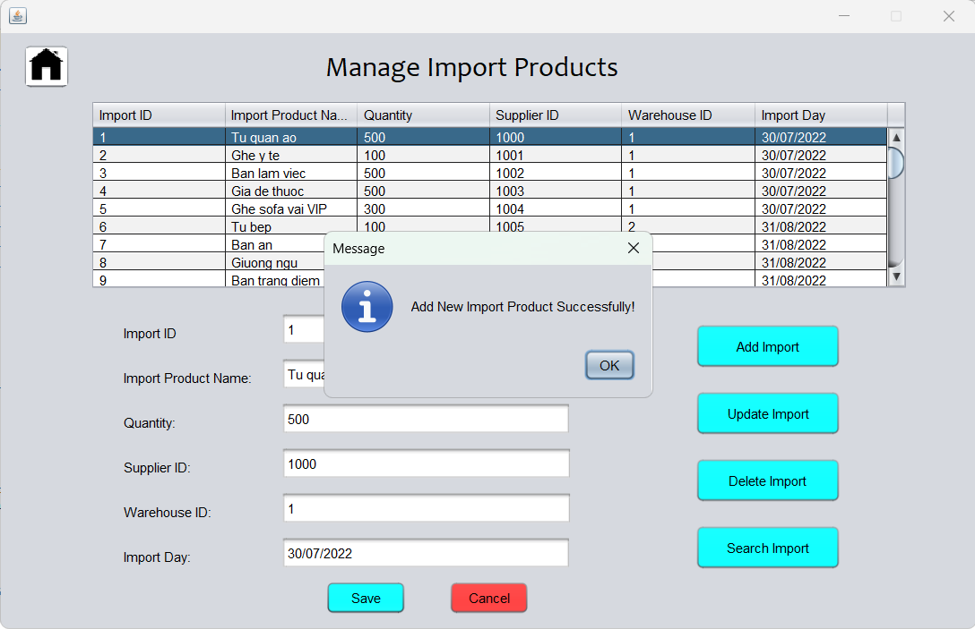

-If there are no further edits, click "Cancel" to return to the main interface of manage import product.



-Click "DELETE IMPORT" to scroll to the delete information page.



-Delete import product information by importID, click on importID you want to delete or you can select directly on the above dashboard. Then press "DELETE" to delete.

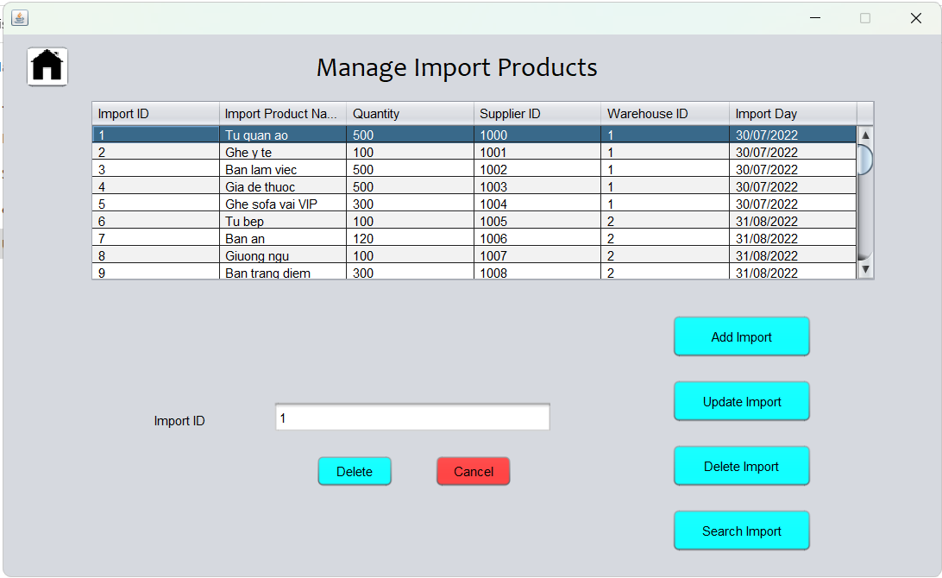

-The system will show a successful deletion message.

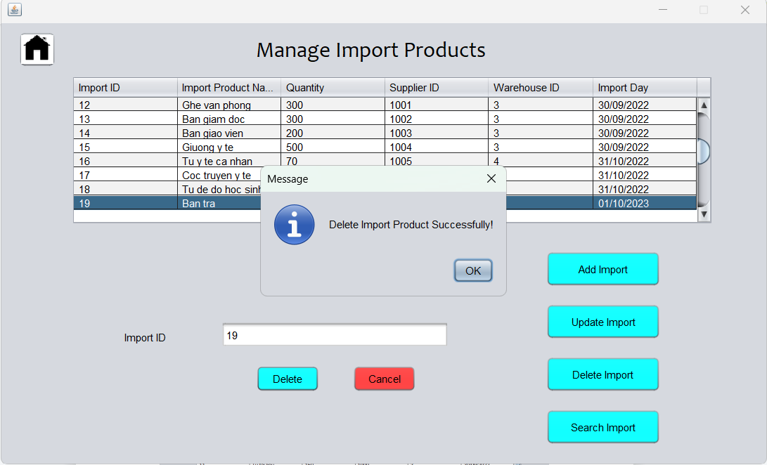

-Press Cancel to return.



-To search for import product, click on "search import product", the system will take you to the search page.



-At the search box you can search for import product by ID, Product Name, Quantity, Supplier ID, WarehouseID, import date.

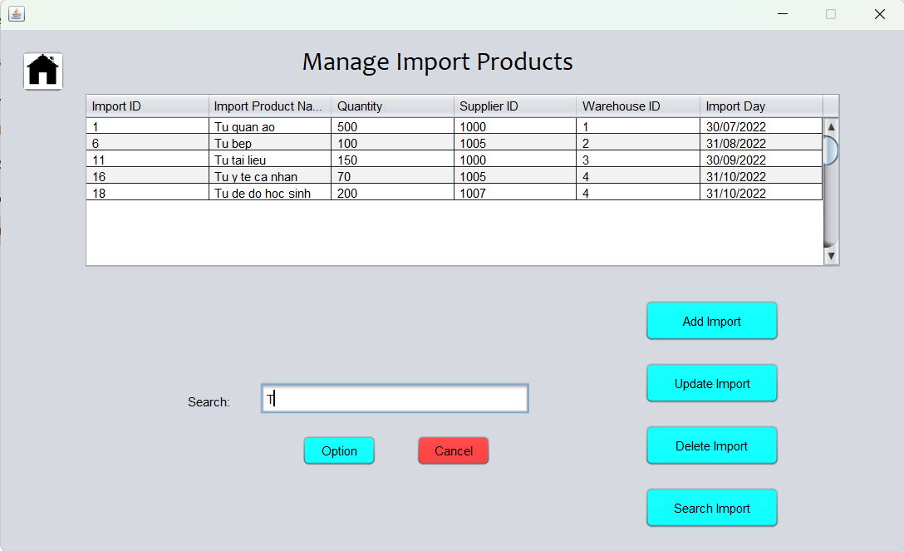

-Click Cancel to return to the import management page.



-Click the home button to return to the Manage interface.



**\*Note**: We can add, edit, delete, search for information directly with the above buttons without having to go back to the Manage Import Product page.



1. **Manage Staff**

-Click on Manage Staff to navigate to the Manage Staff page.



-Fill in the appropriate information in each button.

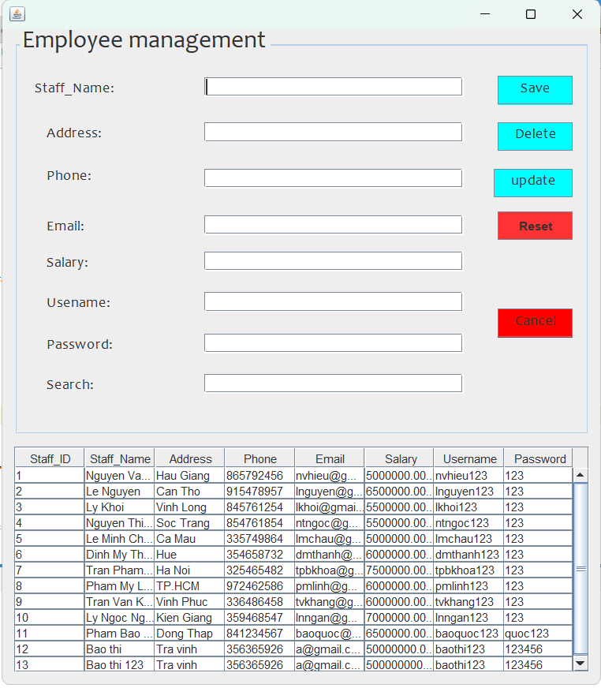

-Click "SAVE" to save the information.

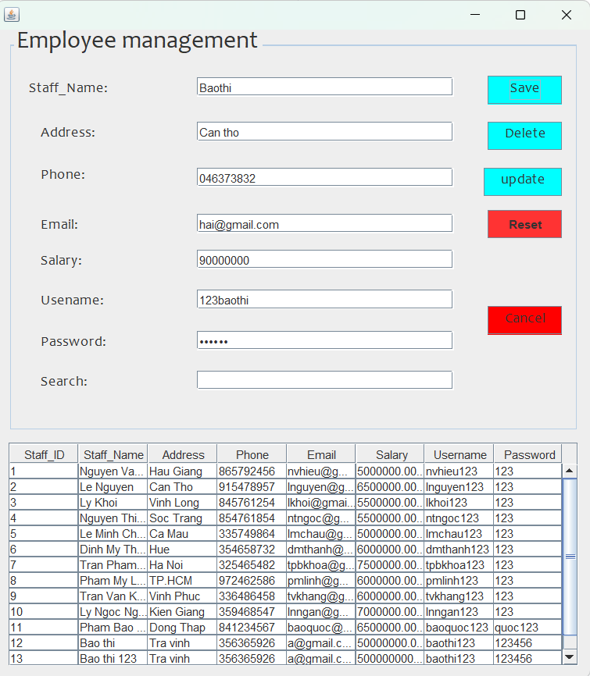

-If you enter all information, the system will notify you that the new addition is successful.

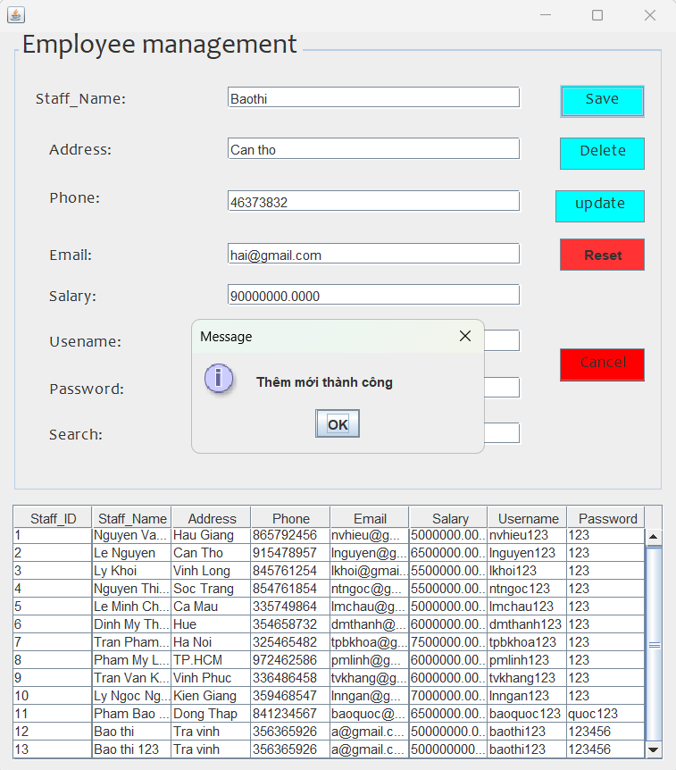

-Click OK to turn off notifications.

-Select the information you want to edit in the dashboard, click UPDATE to update the information.

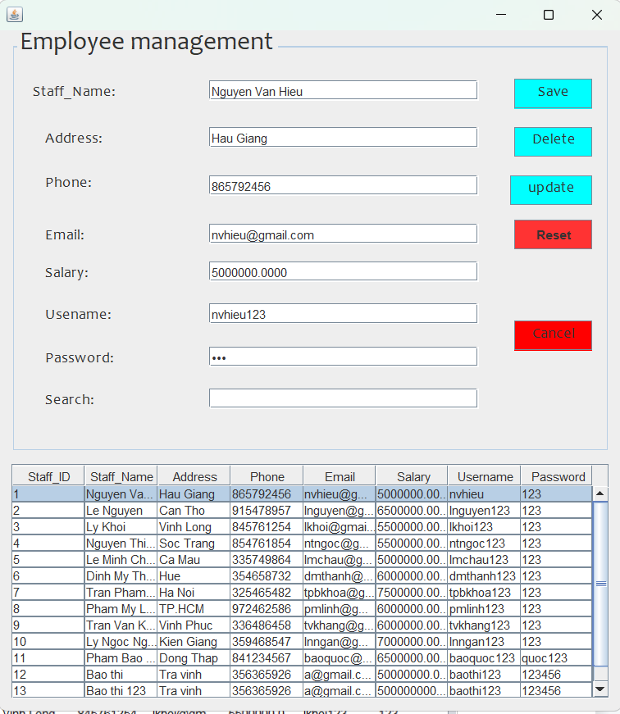

-The system will notify the update successfully if the information is valid.

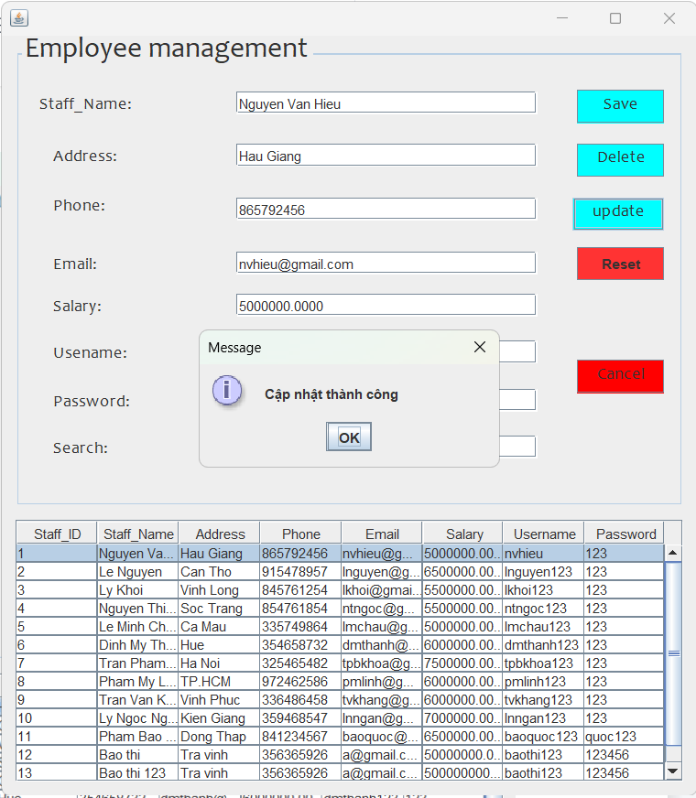

-To delete an employee, you need to select the employee information in the dashboard and then click the delete button to delete.

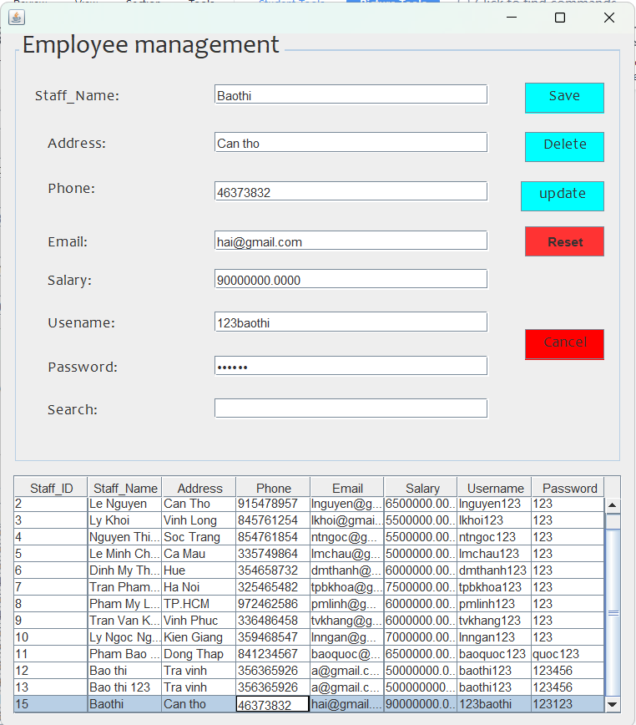

-The system will notify if you delete successfully.

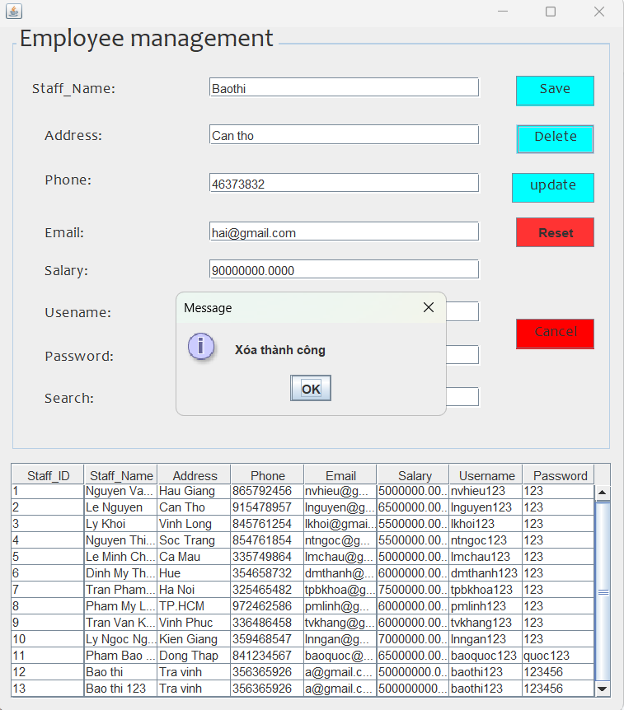

- Search for employee information at the search box. We can find the full information of the employee.

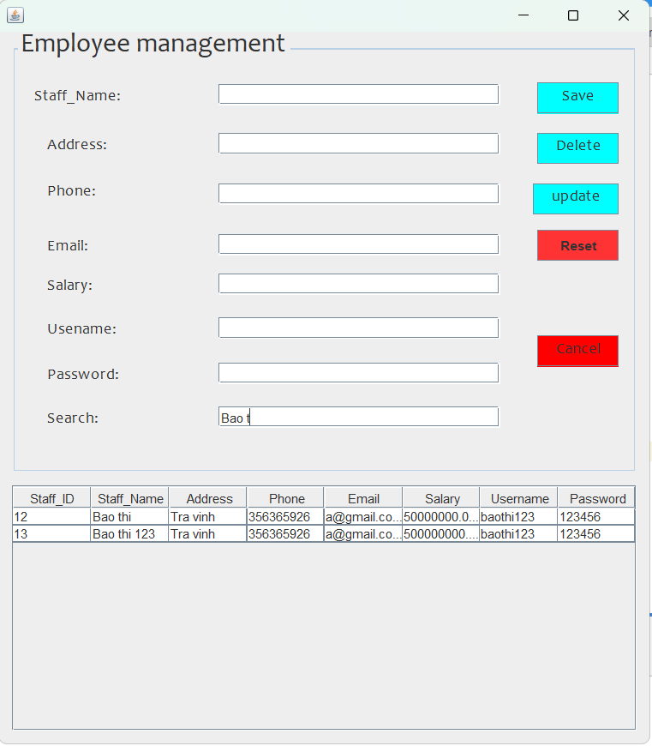

-Press reset to return to original state.

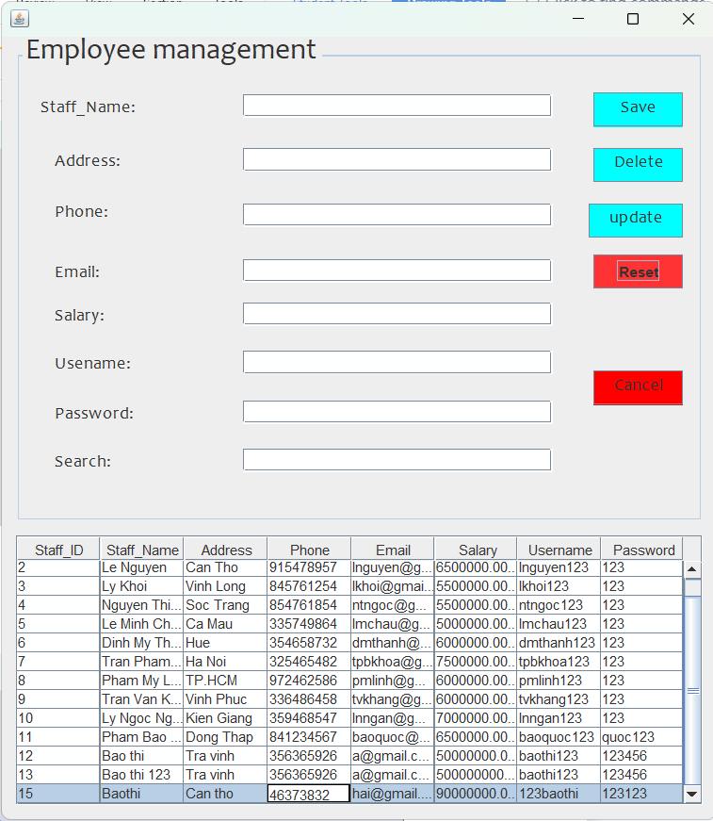

-Click Cancel to return to the Manage page.





-Clicking on Import Statistics will display a graph of the total number of products in each warehouse.

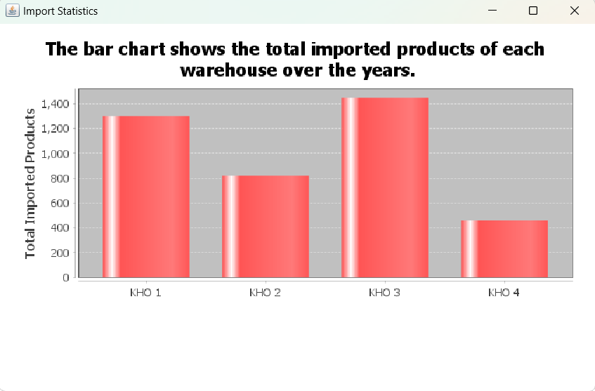

-Click on the admin image to log out.



**II.Staff**

-This is the employee's store management section.Clicking on Staff will bring up the login page.



-Change button to change the employee's password.

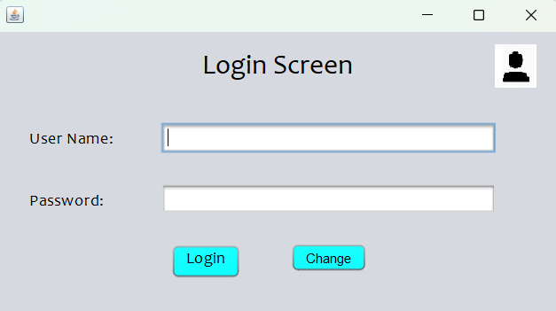

-The cancel button has the function of returning to the login page if you do not want to change the password

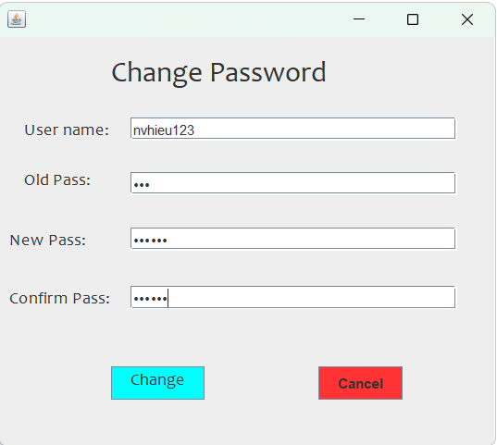



-Enter old and new username and password. Click change to change the password.



-The system will display a notification of successful password change.

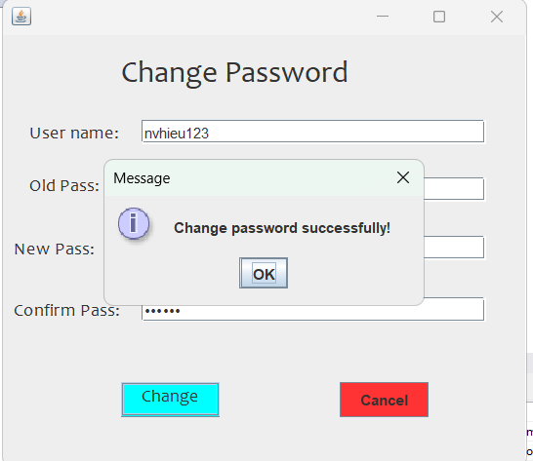

-Enter employee account information.



-Click login to login.

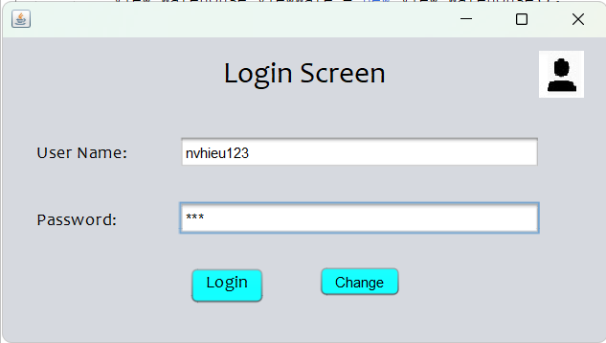

-This is the main store management interface for employees.

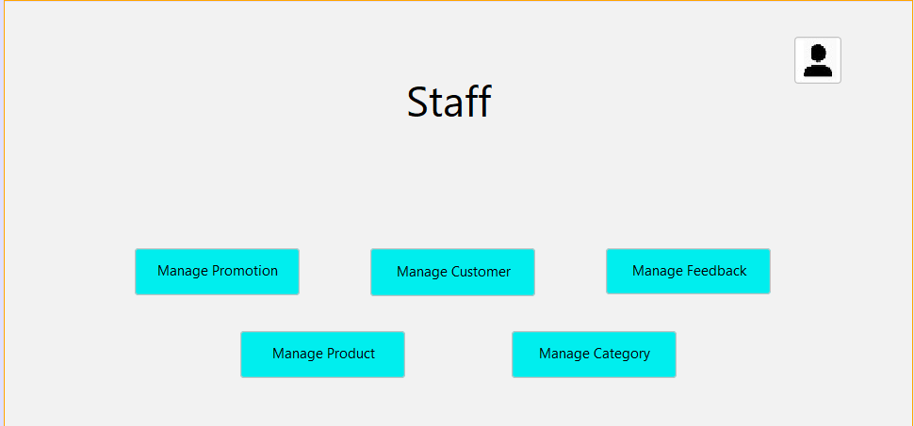

1. **View Product.**

- Manage the store's products.



- This is the interface of the product management section.

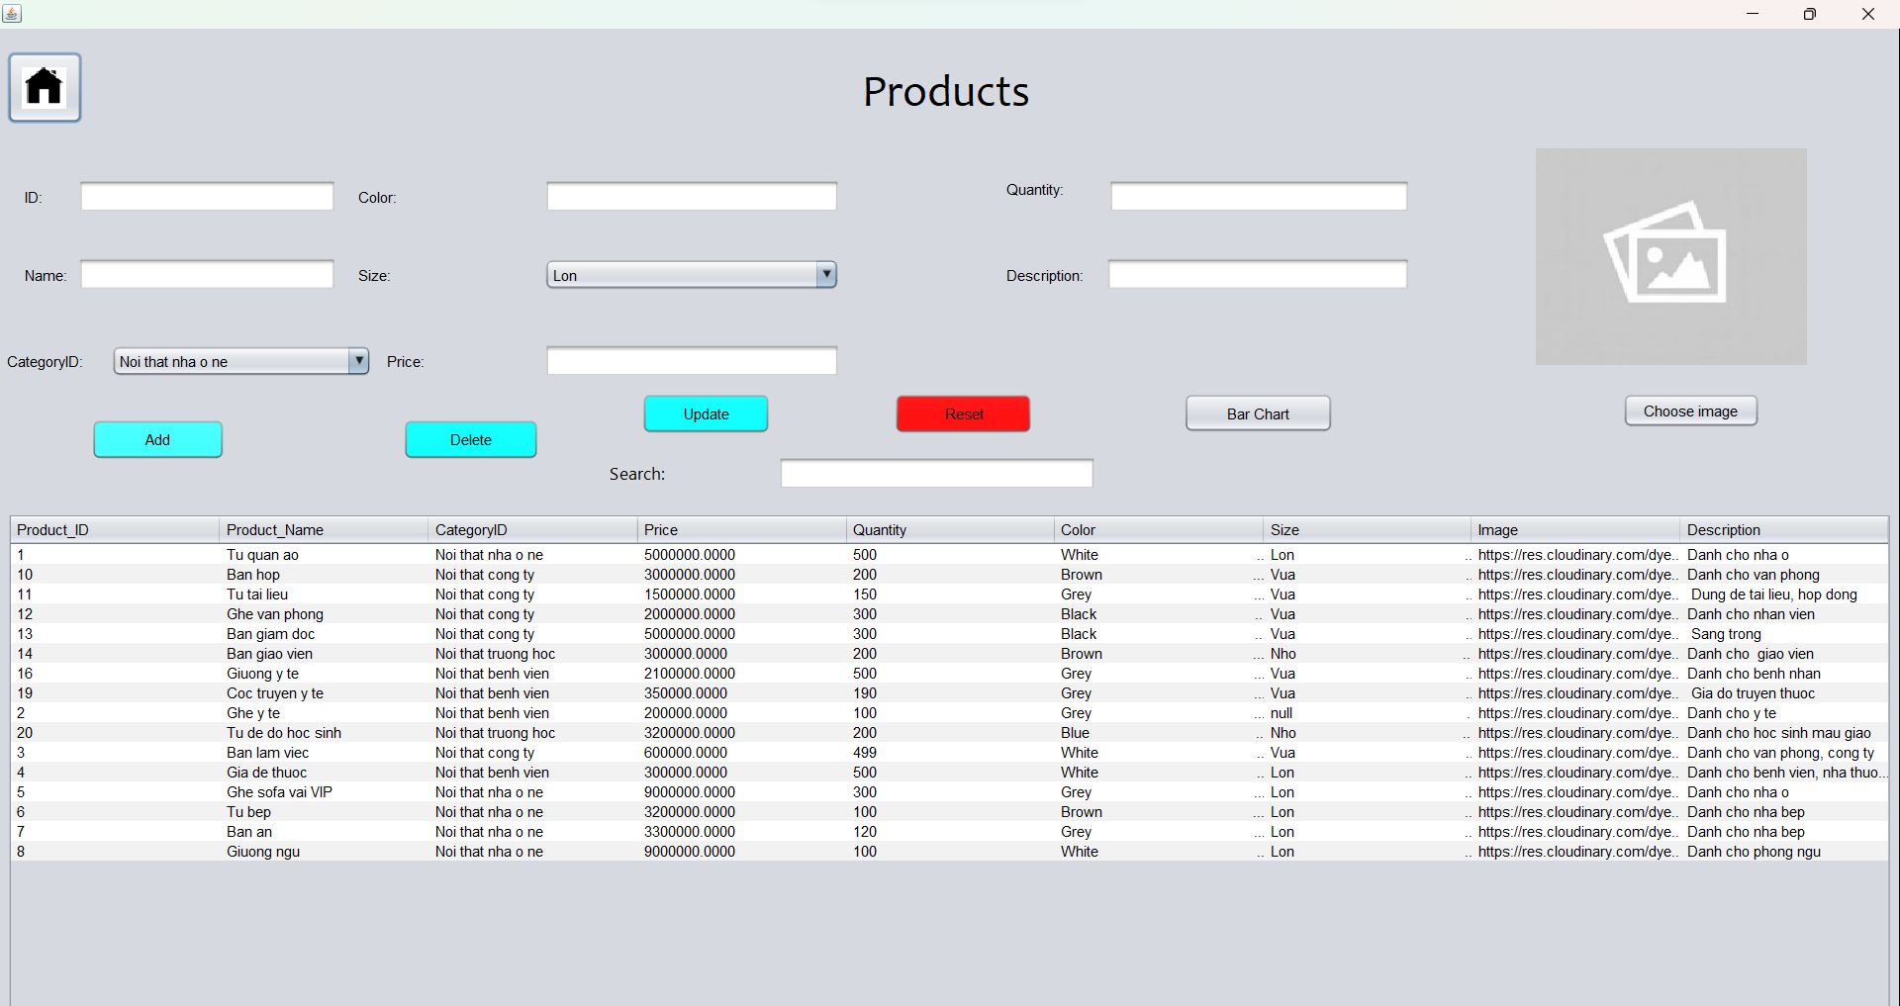

-Add products: Fill in the necessary information in the boxes. Click choose image to select an image.

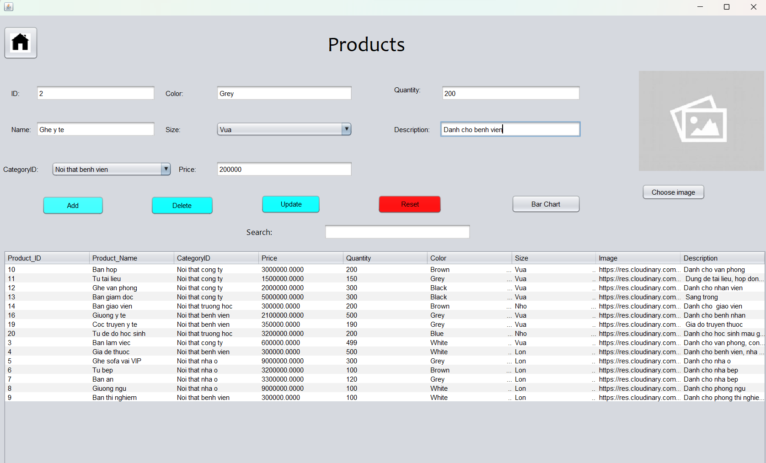

-The system will go to the image selection interface, select the image you want and click the open button.

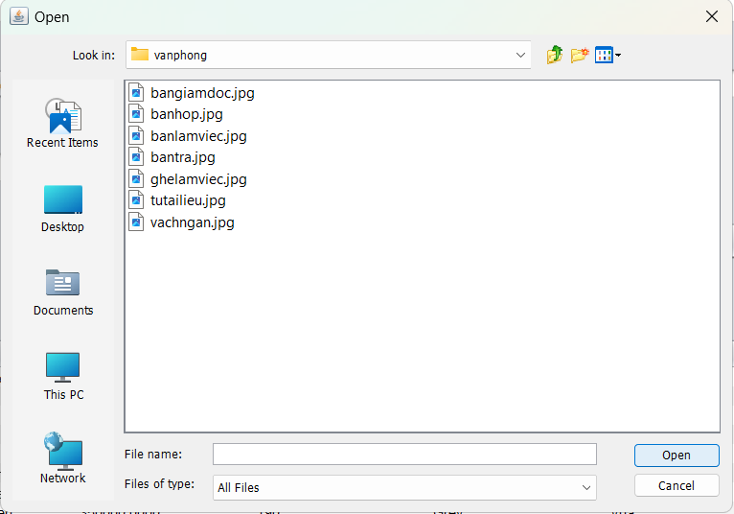

-Click ADD to add the product.

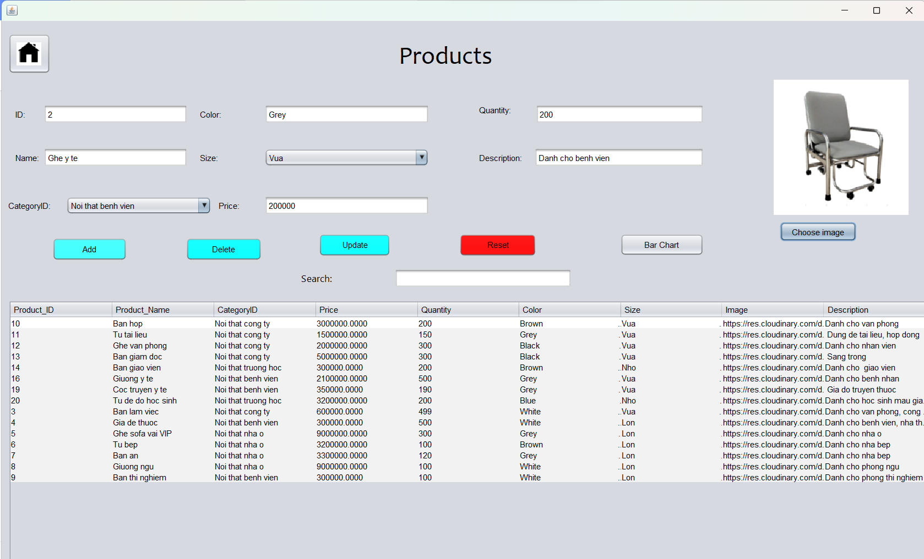

-If the information is valid, the system will say "Add successful".

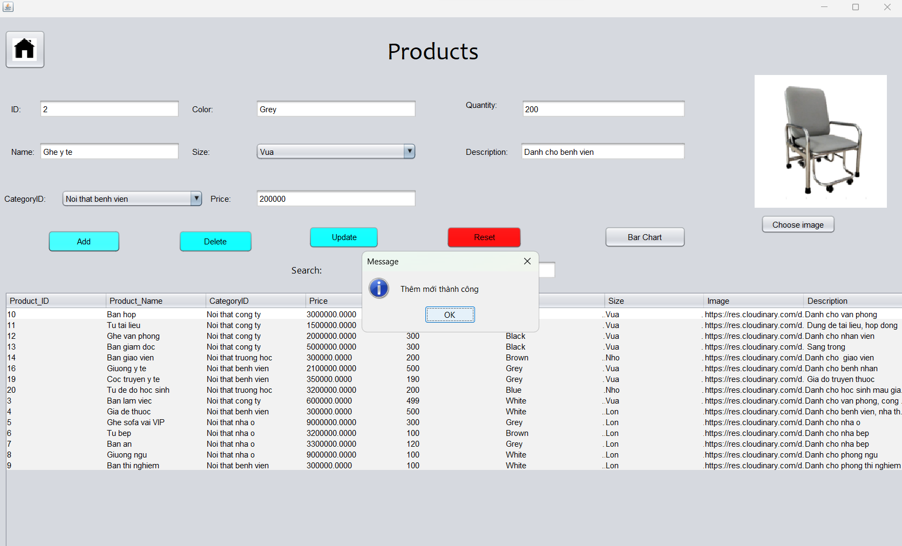

- Click on the product you want to edit in the information panel. Edit the required information and click the UPDATE button.

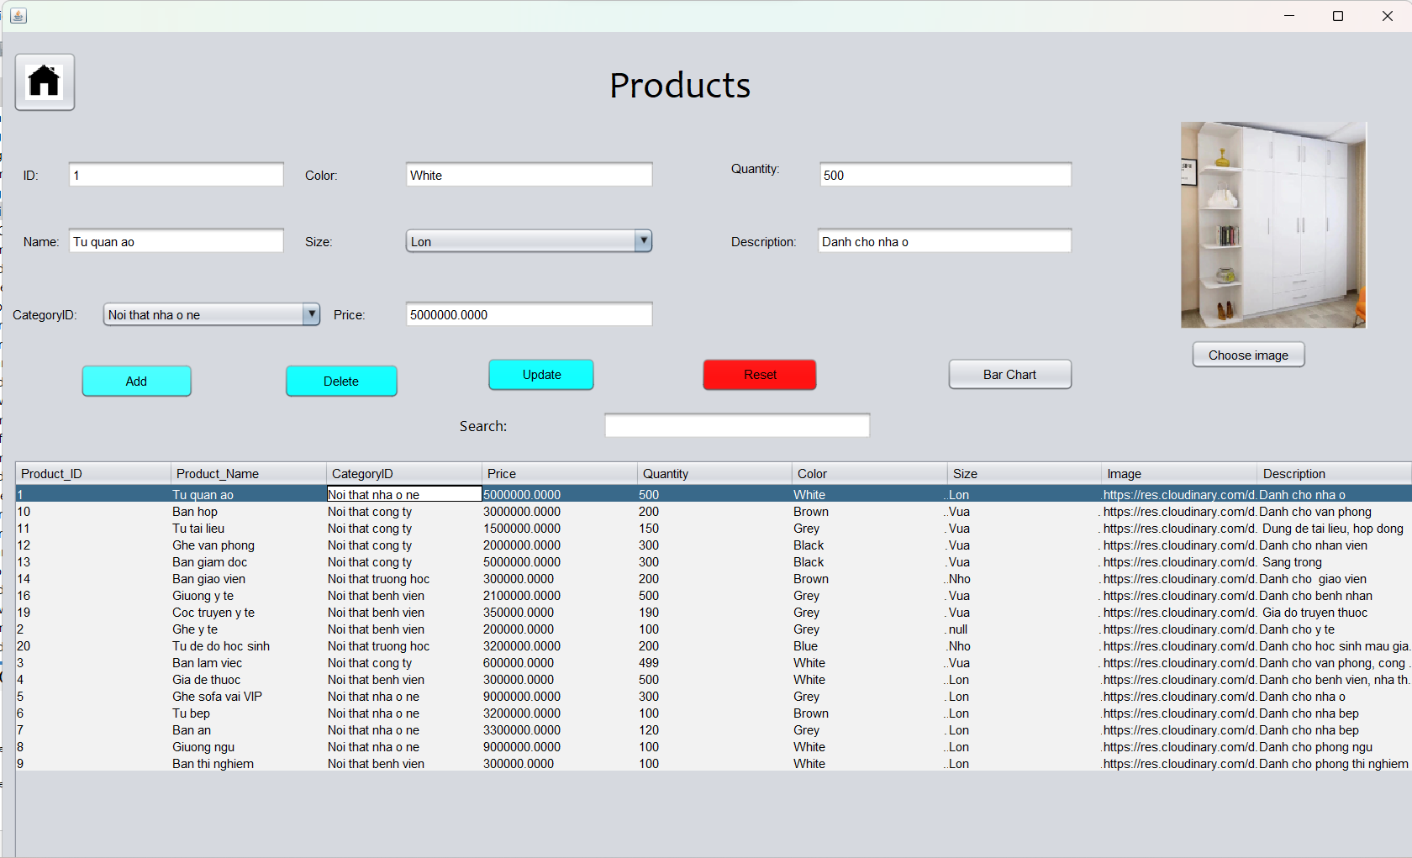

-The system will notify the update successfully.

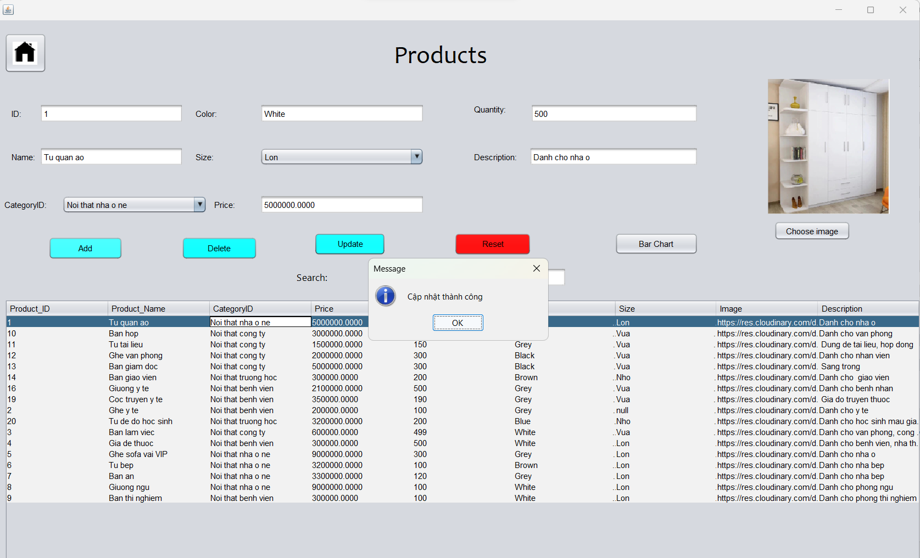

-To delete a product, click on the product you want to delete in the dashboard. Then click the "DELETE" button.



-The system will display a notification giving you 2 options. If you select NO, the product will not be deleted. If you select YES, the system will display a DELETE SUCCESSFUL.

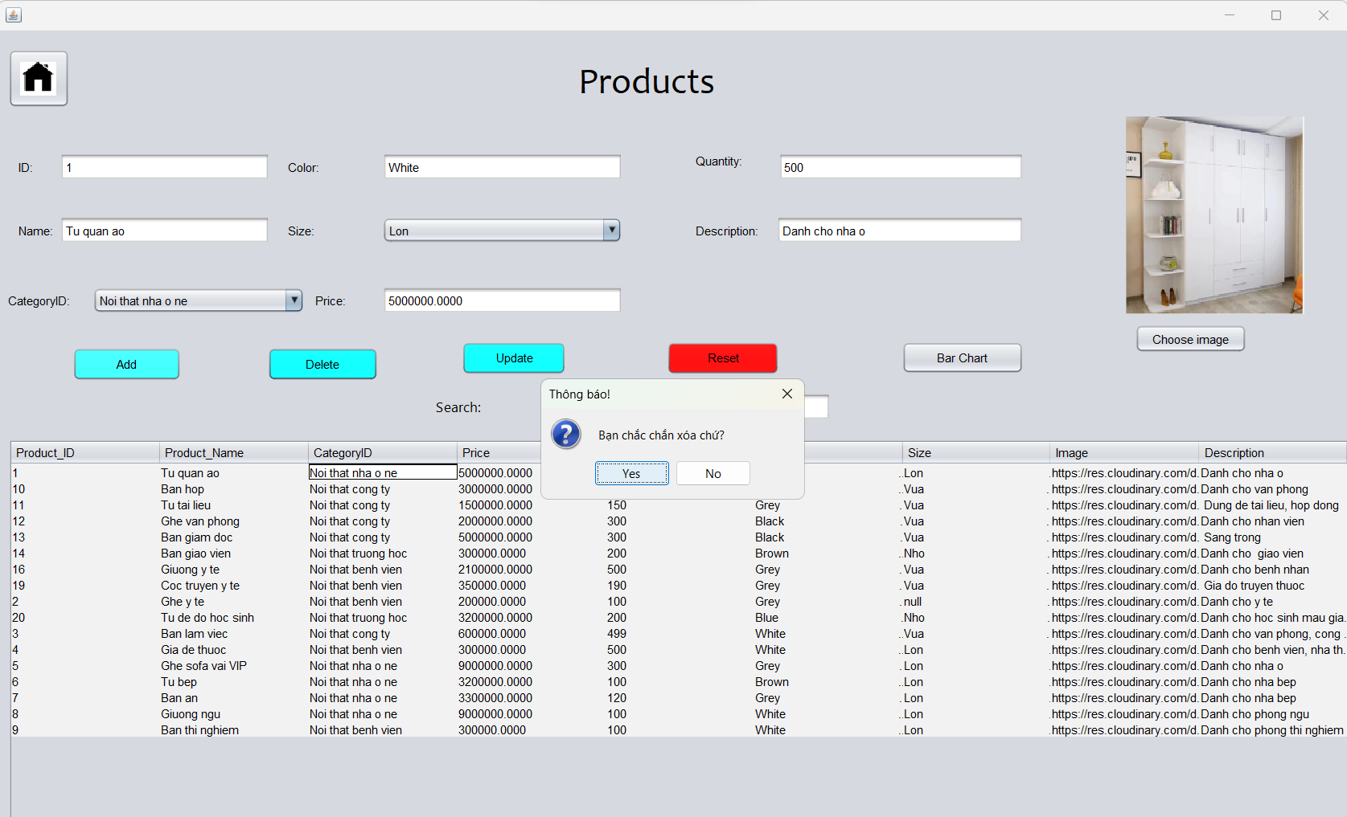

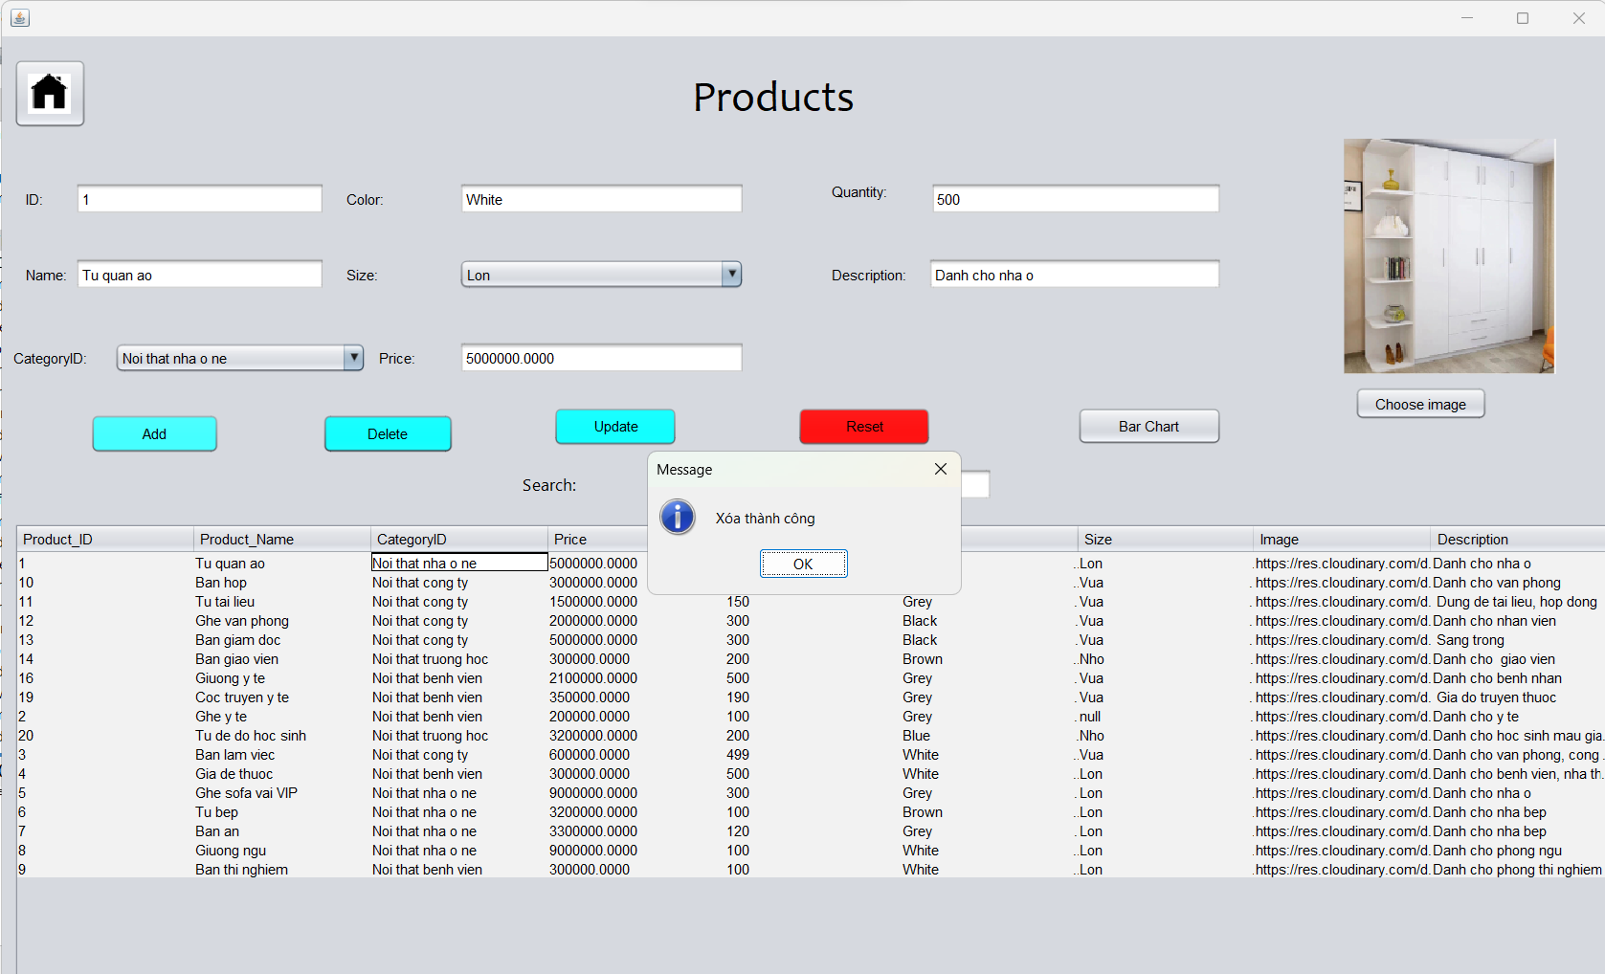

-Click OK to turn off notifications. Click reset to return to its original state.

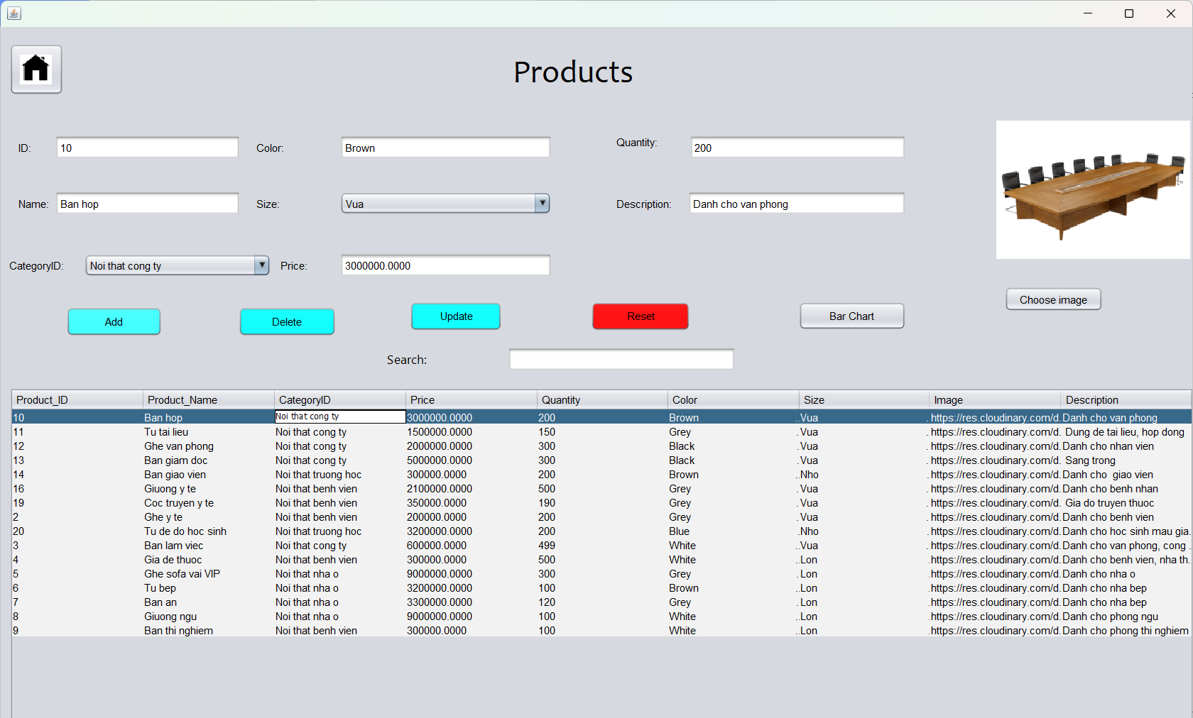

-Here there is the Bar Chart button. Here's a chart of which specific category the product belongs to.

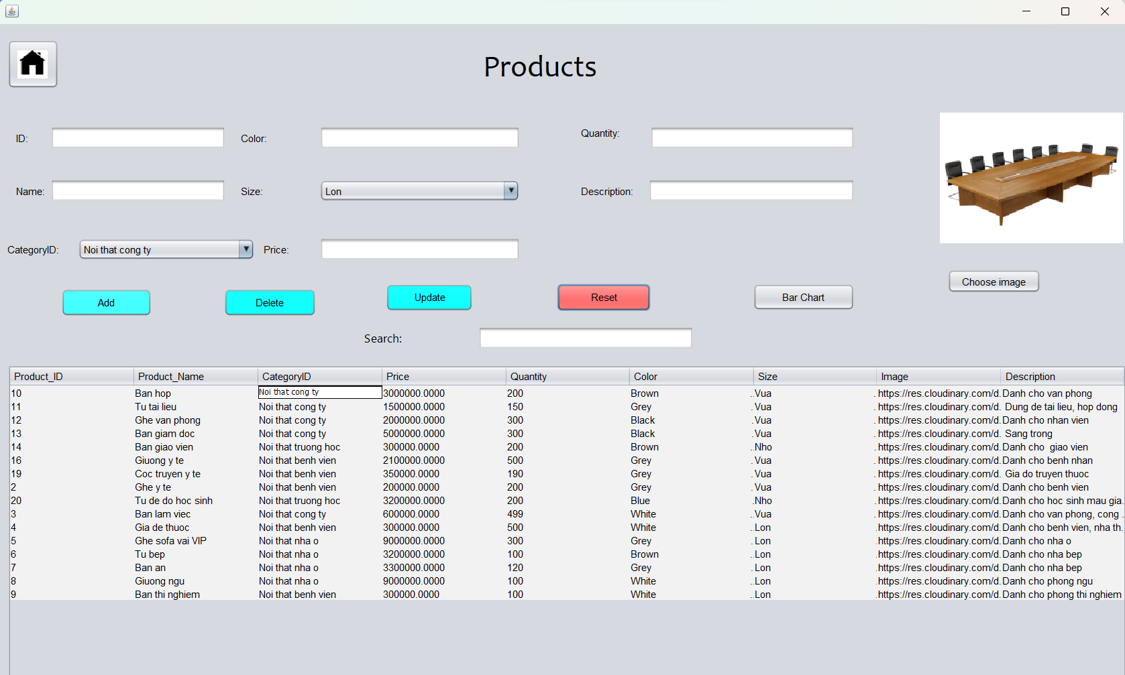

-The columns show the number of products in a specific category.

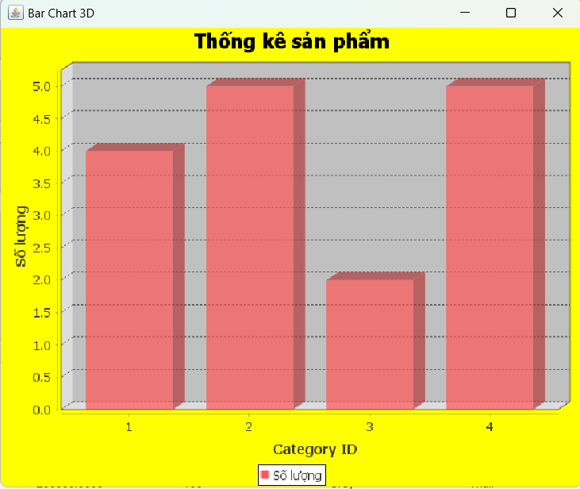

-Click the home button to return to the employee management interface.





1. **Manage Category**

-This is the catalog management page of the store.



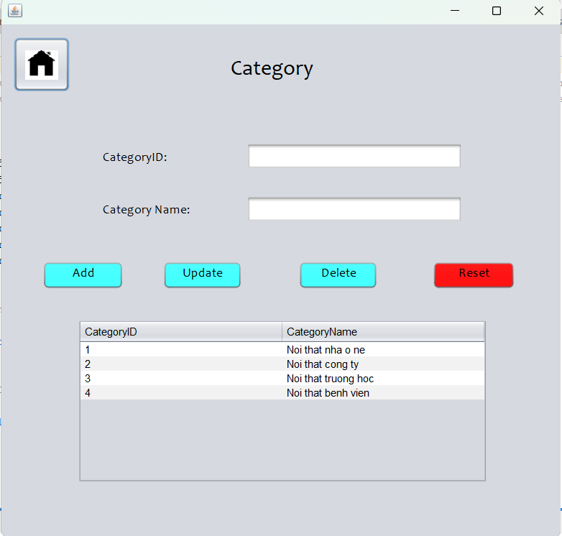

- To edit the category, click on the category in the information panel, edit as you like and click the UPDATE button.

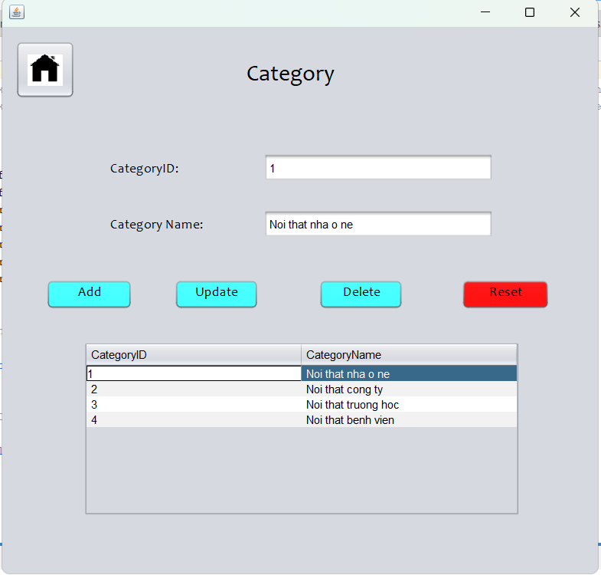

-The system will display a successful update notification.

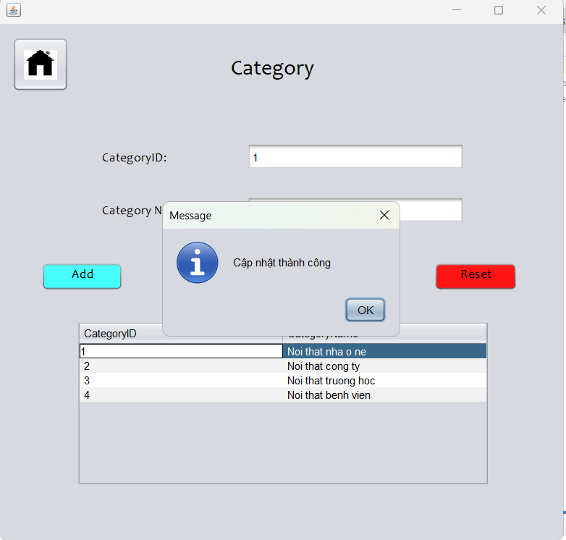

-To delete a category, select the category you want to delete and press the DELETE button.

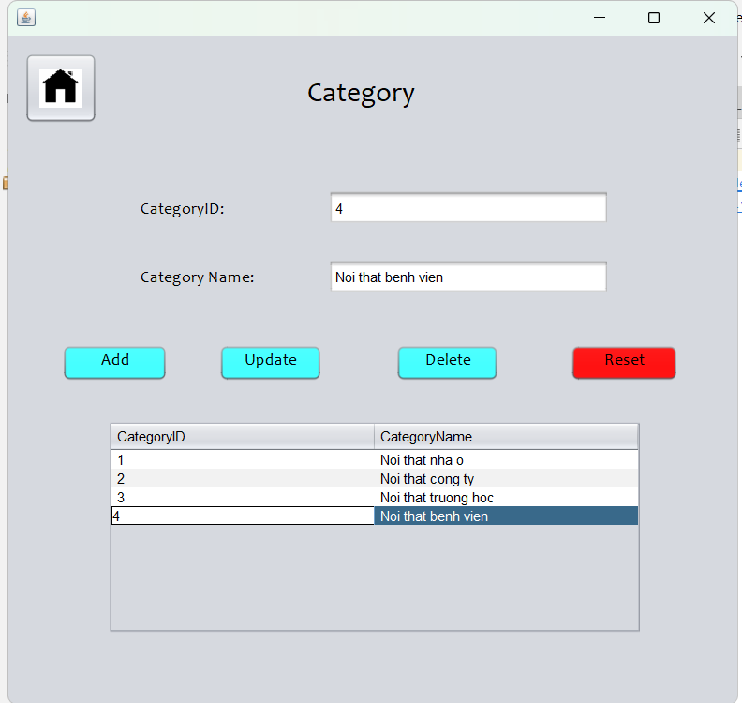

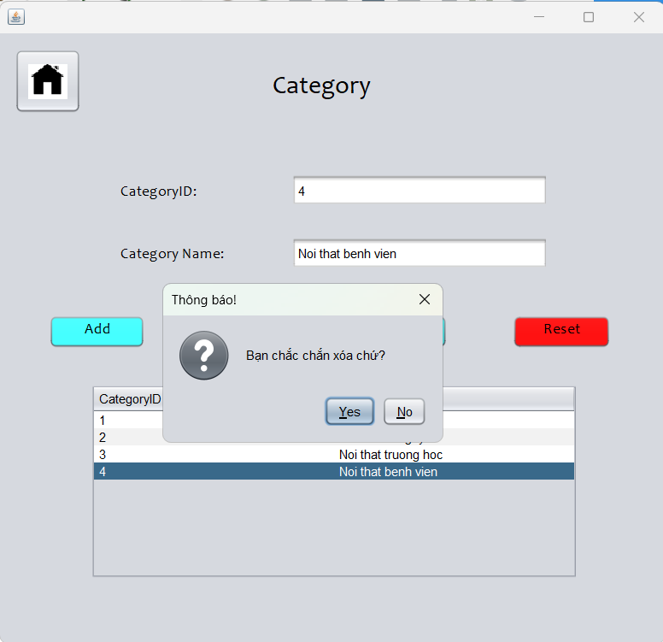

**\* Note**: A category with products inside won't be able to delete it.

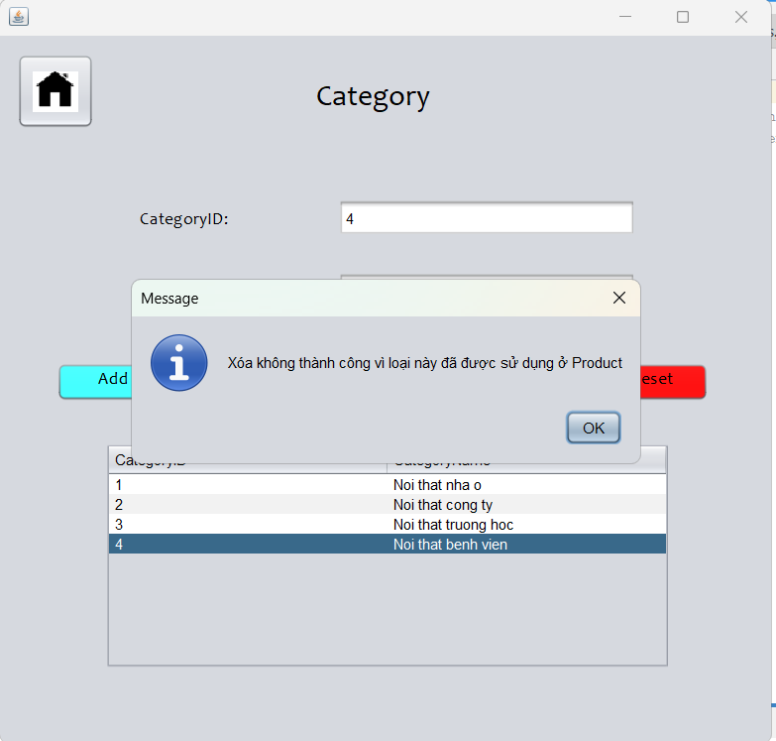

-Fill in the list you want to add to the box and press the ADD button.

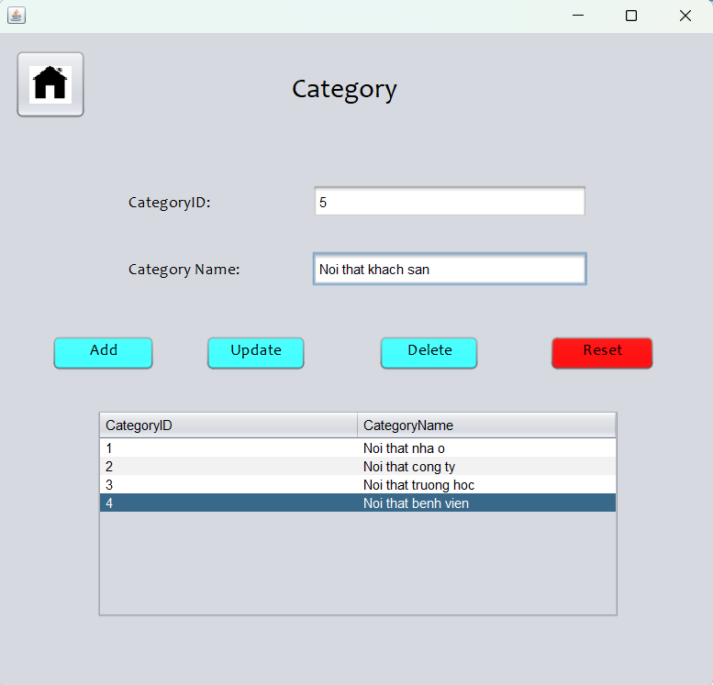

-The system will display an additional success message.

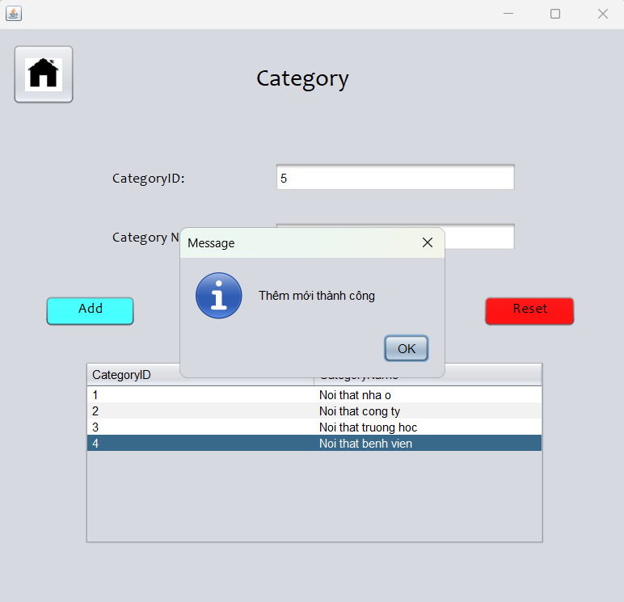

- The new category doesn't have products inside yet, so we can delete it. Select the newly added category and press the DELETE button.

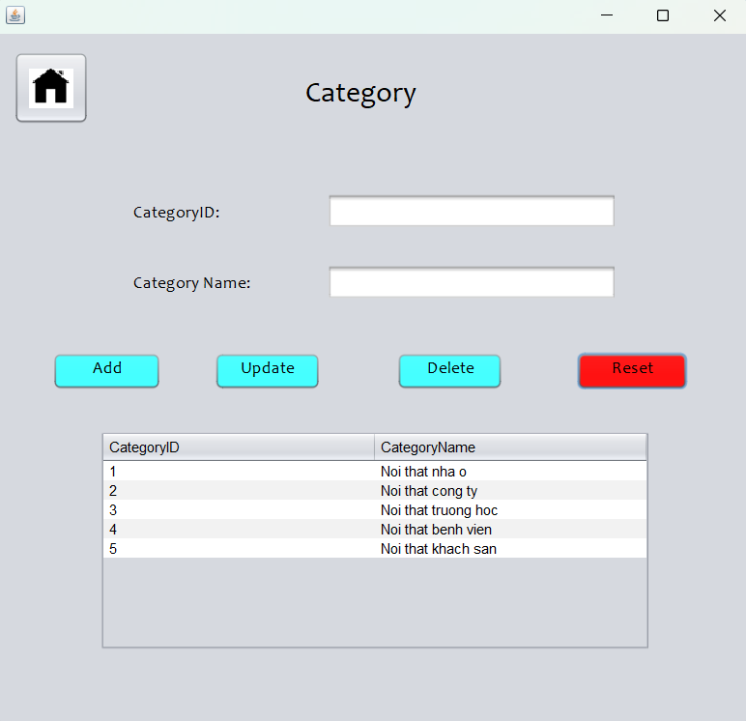

- The system will ask if you want to delete this category. Press YES to delete the category.

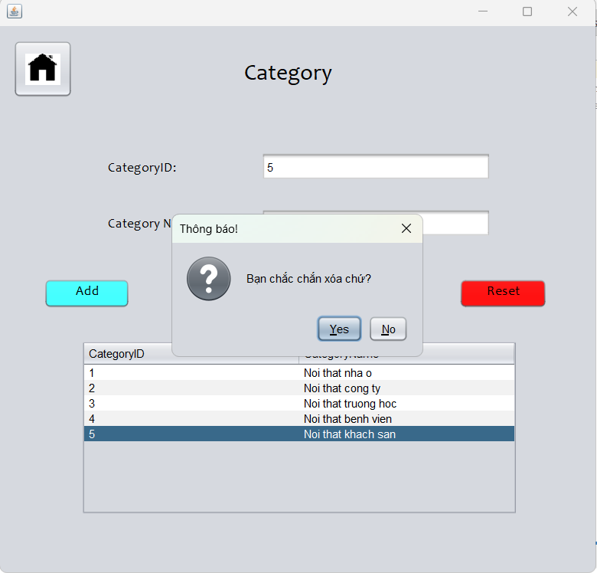

-The system will display a successful deletion message.

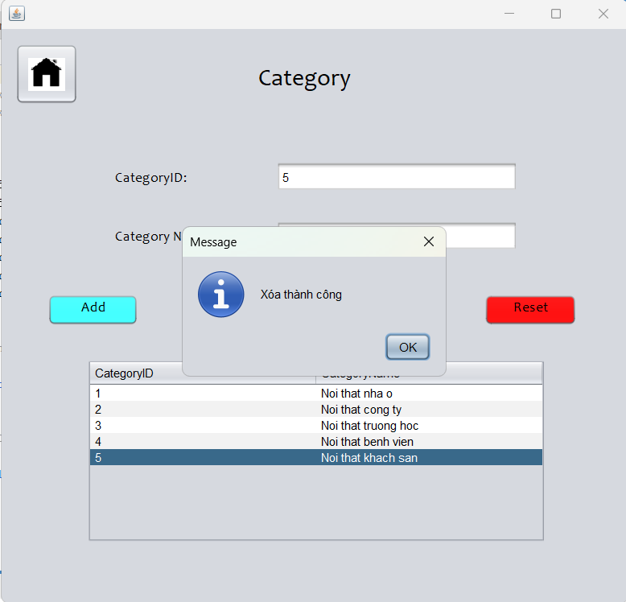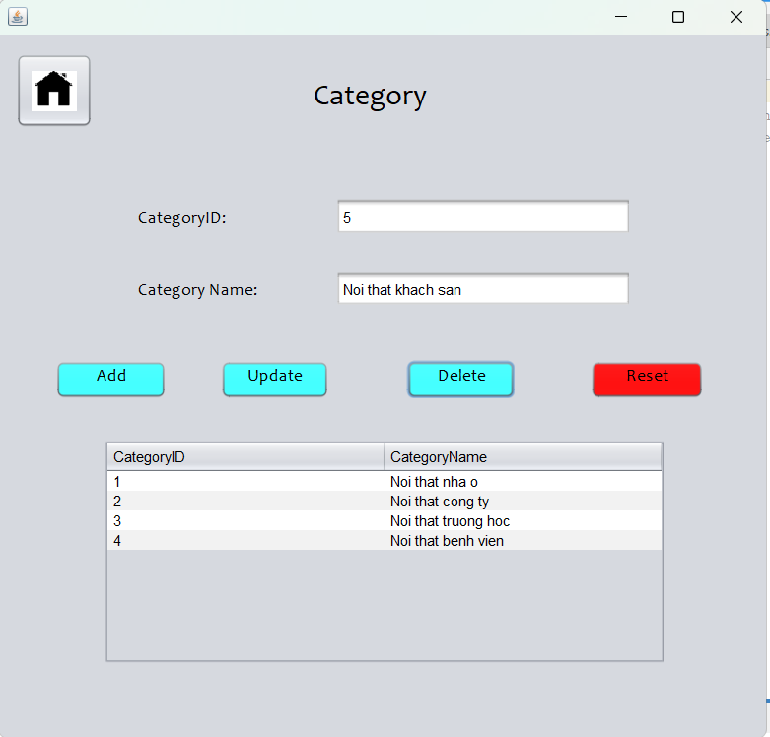

-Click reset to return to the original state.



-Click the home button to return to the Staff interface.



1. **Manage Promotion**

-This is the part of managing the store's coupons. The voucher is applied to all products in the store.



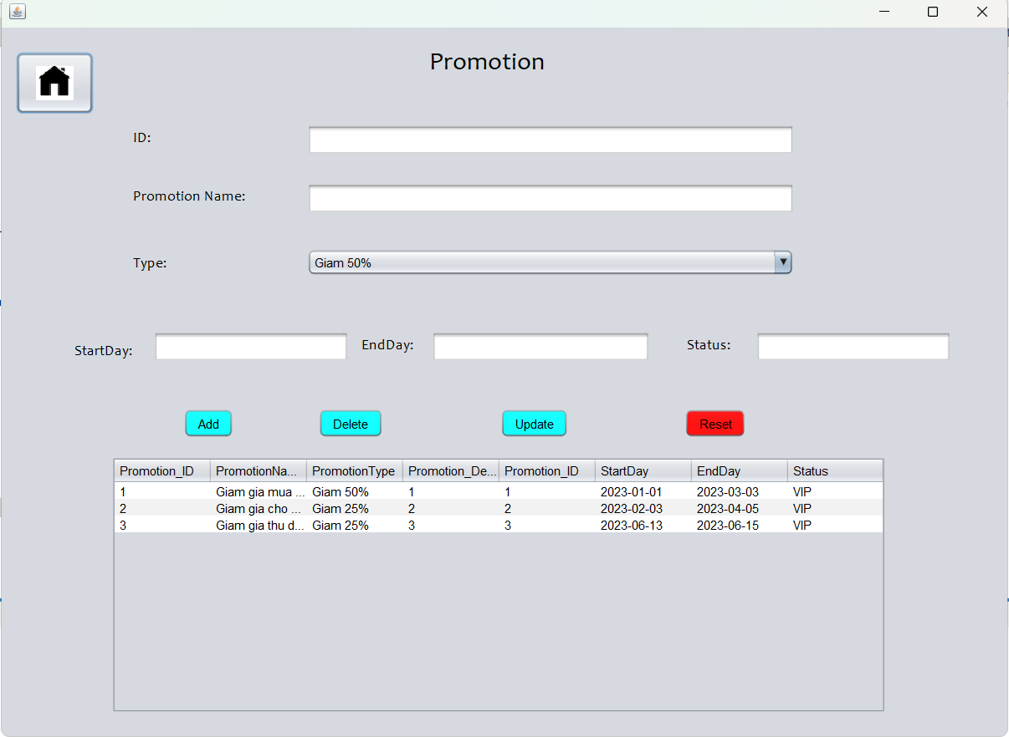

-Select the information you want to edit in the dashboard and click the UPDATE button to edit.

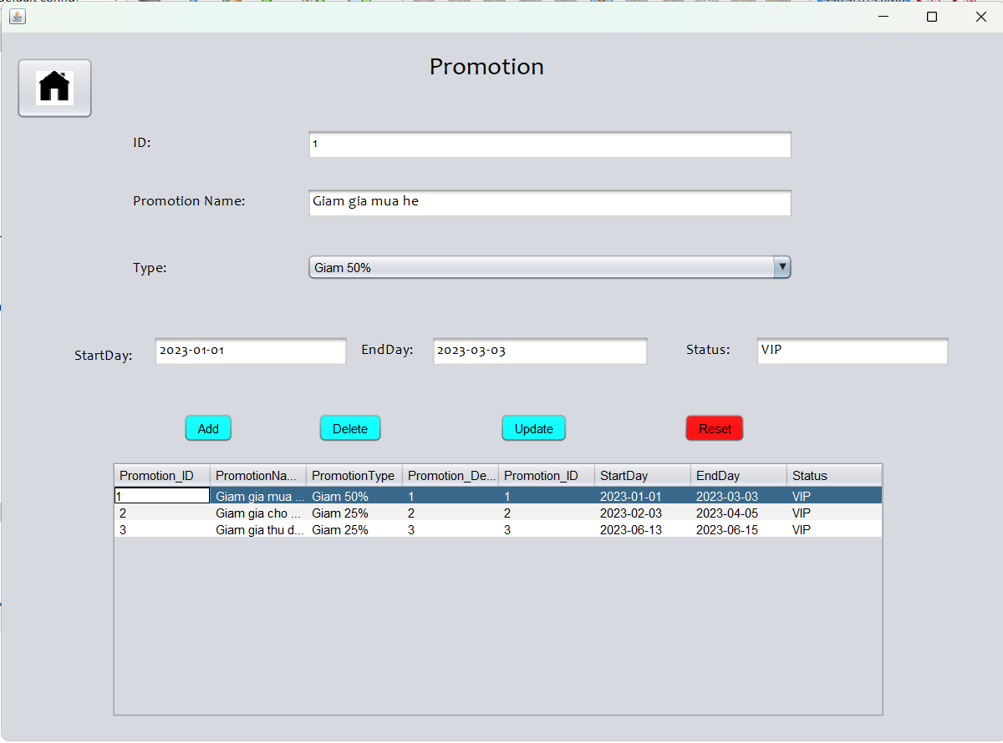

-The system will notify the update successfully.

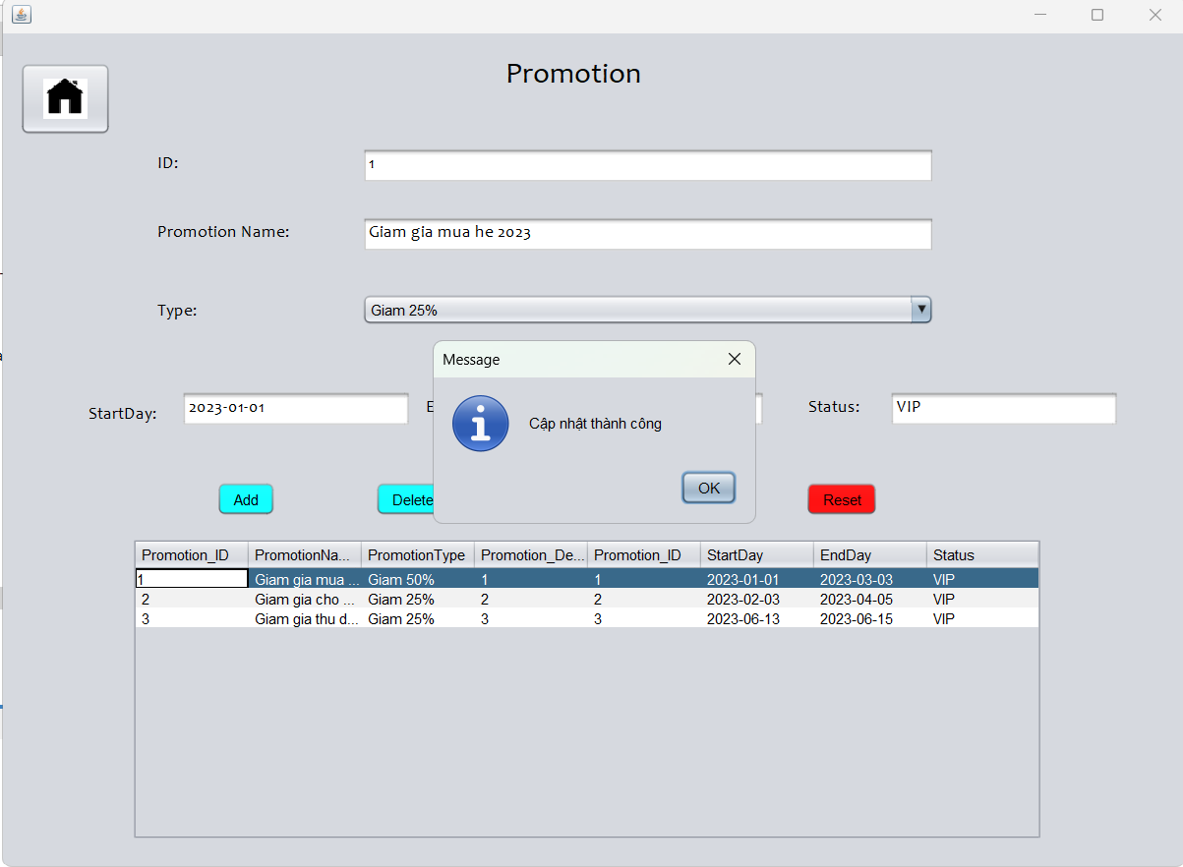

-To add a new code, you need to fill in the corresponding boxes. Then click the ADD button to add the product.

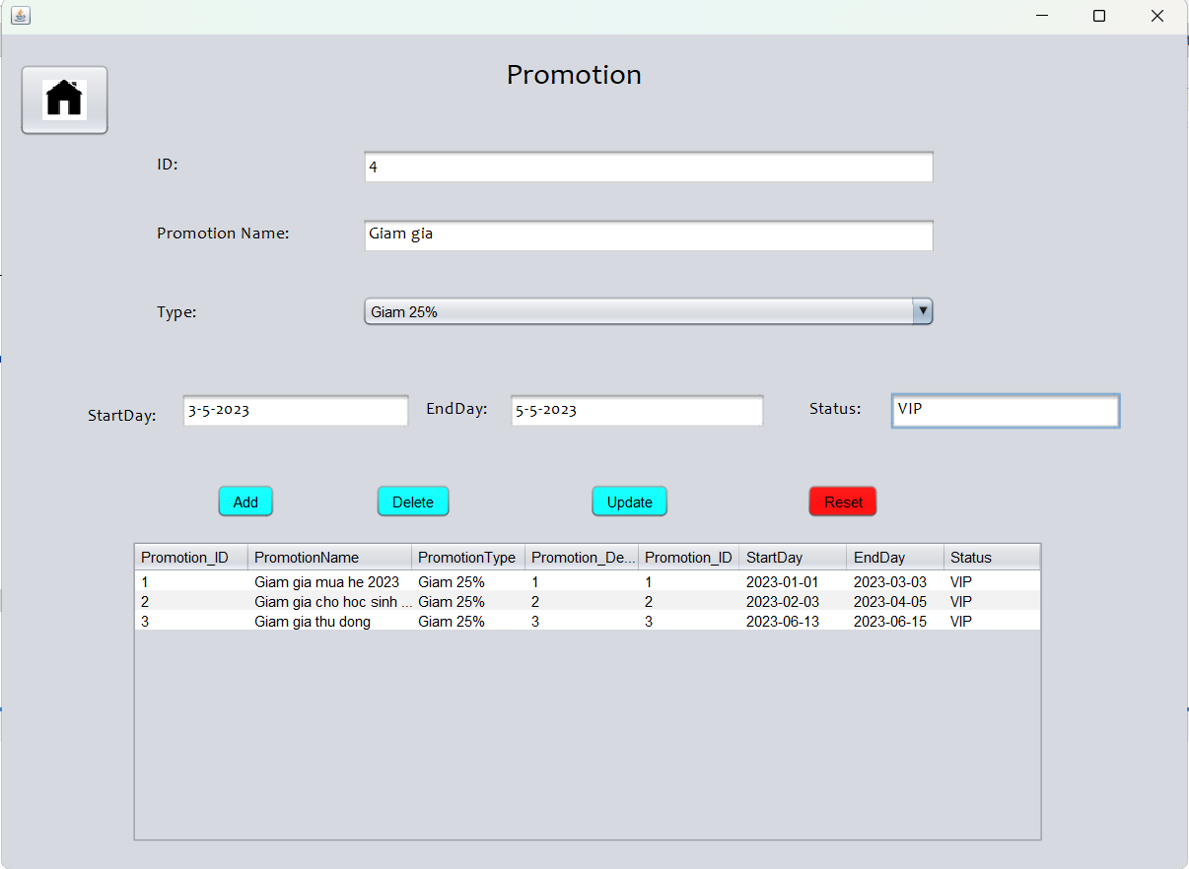

-The system will notify more success if you fill in the information.

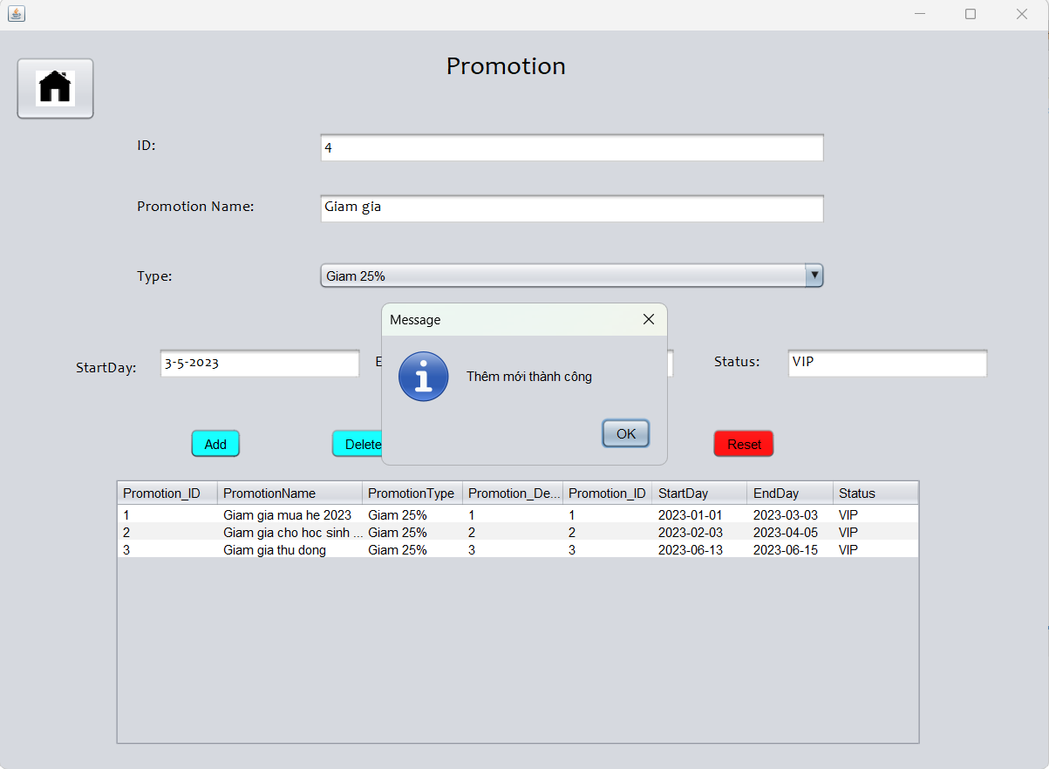

-To delete information, select the information to delete in the dashboard, and then click the DELETE button.

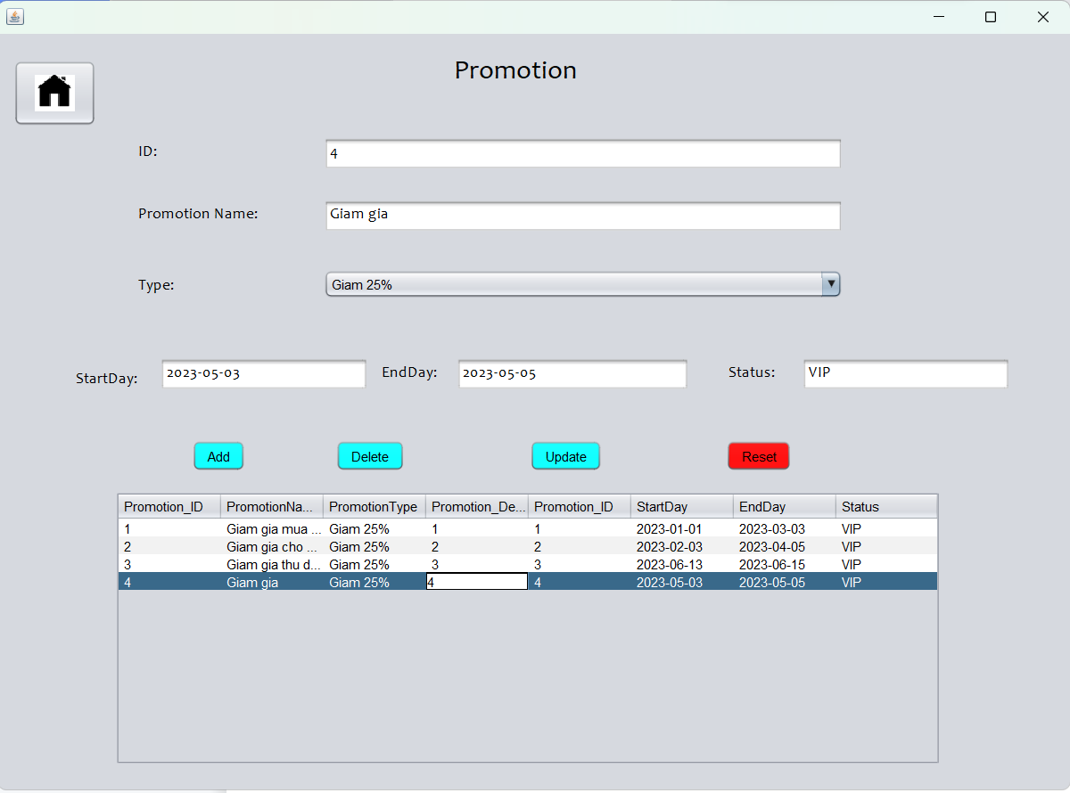

-The system will display a successful deletion message.

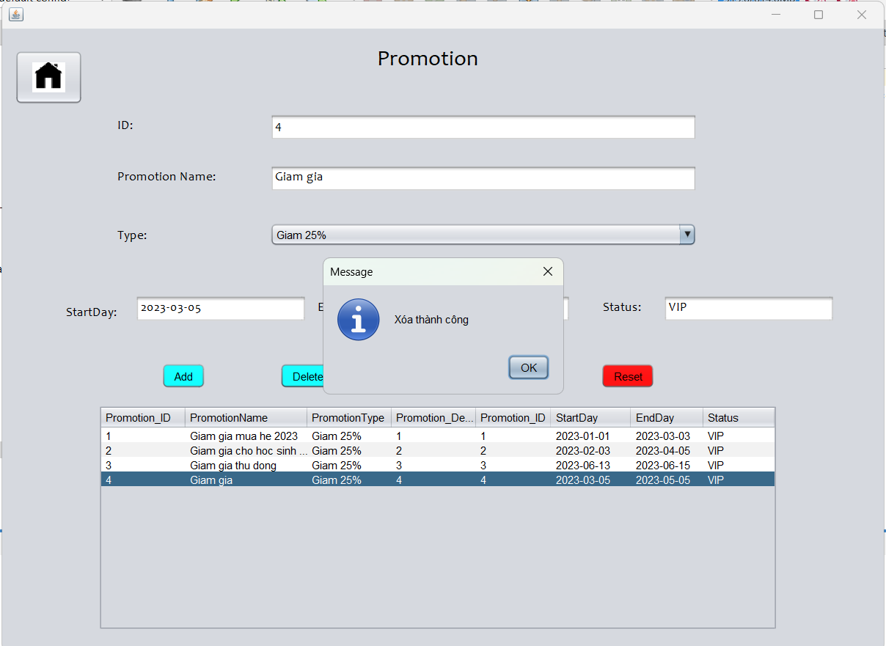

-Press RESET to return to original state.



-Click the home button to return to Staff.

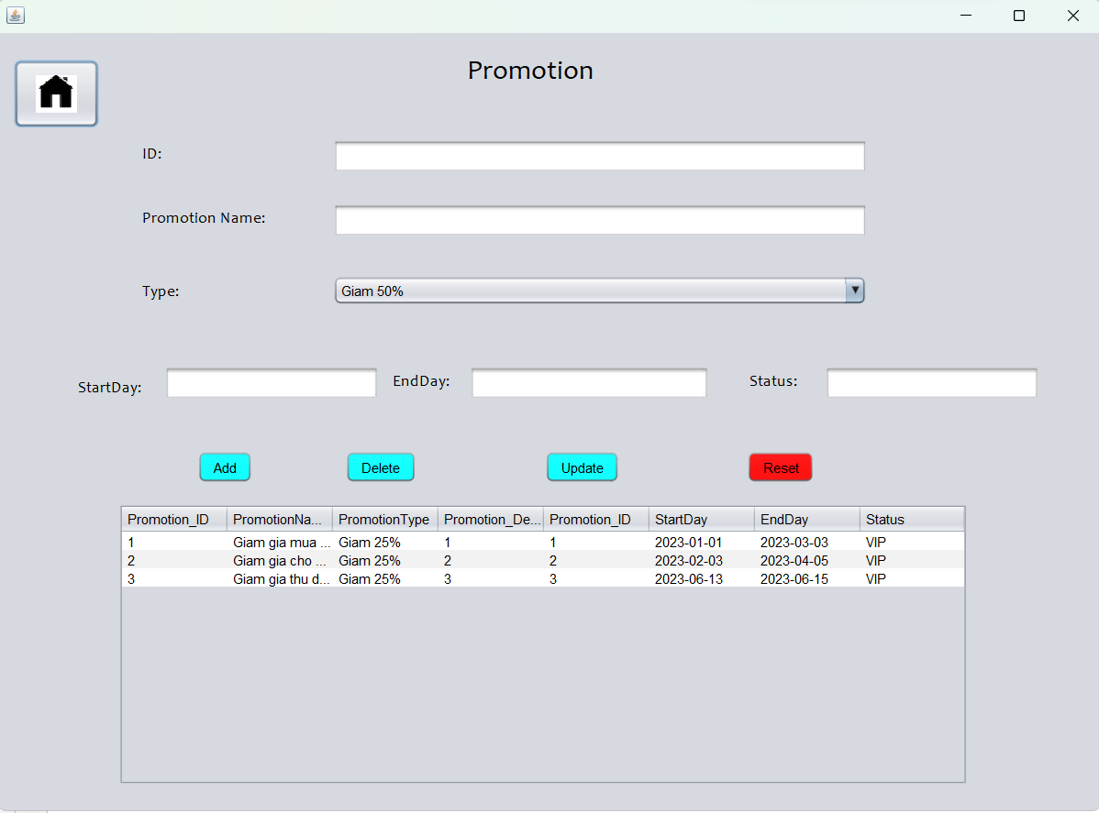

1. **Manage Customer**

- Customer management.



-This is the interface of the customer manager.

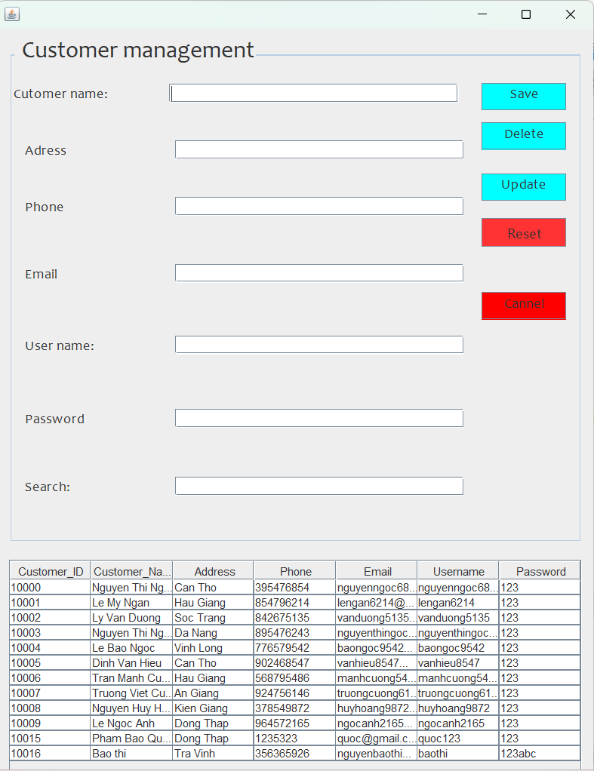

-To UPDATE customer information. Select the customer to update under the dashboard, and then click update to edit.

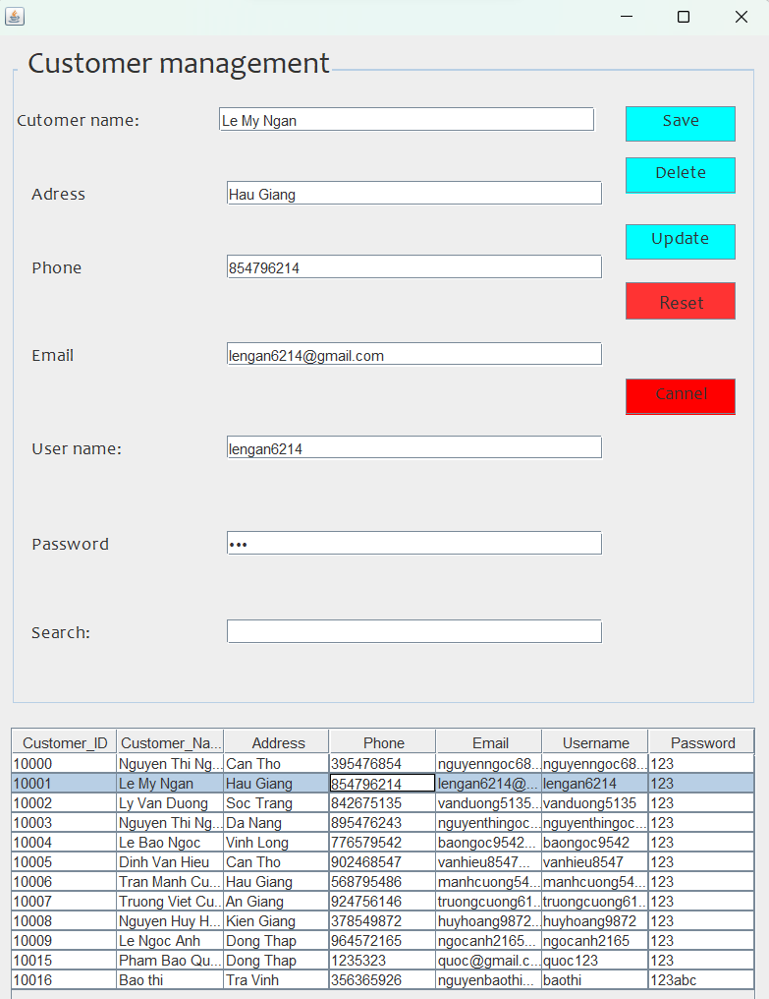

-The system will notify you that you have successfully updated.

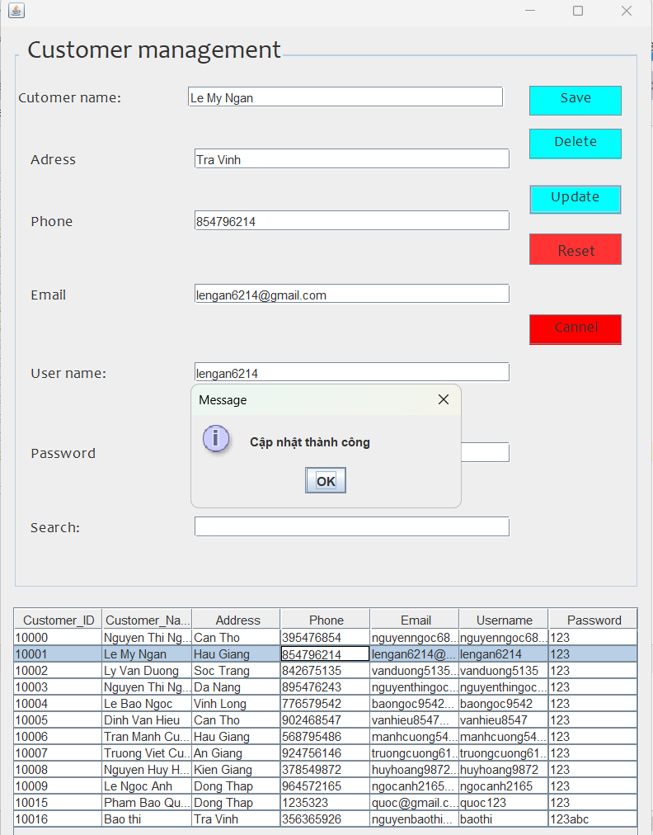

-To delete a customer, select the customer you want to delete in the dashboard, and then press DELETE.



-The system will give you 2 options. Select YES to delete the customer.

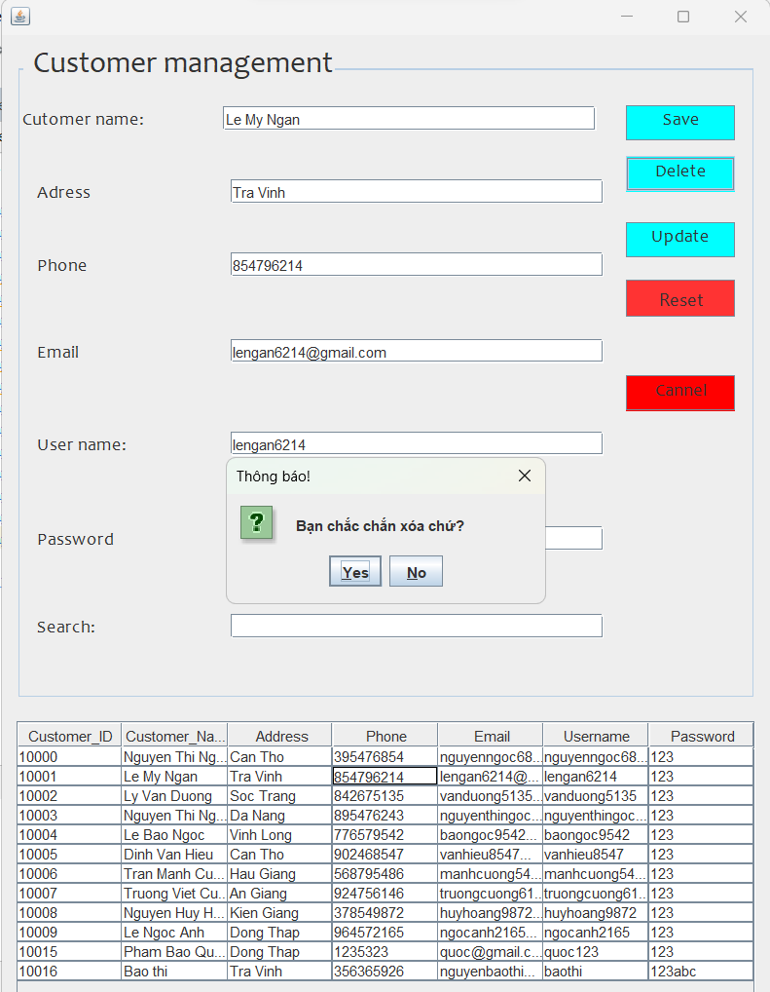

-When the deletion is successful, the system will display a notification for you.

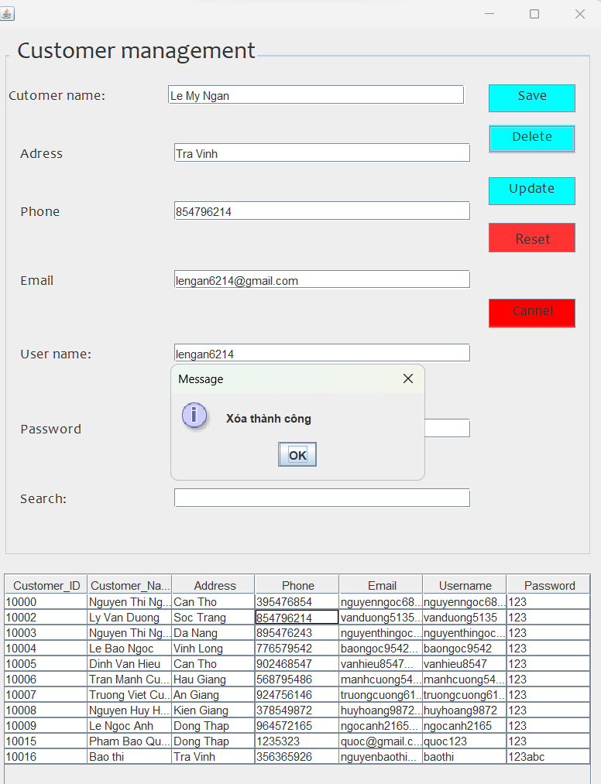

-Add customers: You fill in the checked boxes. Once you've filled it out, click SAVE to add the customer.



-The system will notify you that you have successfully added.

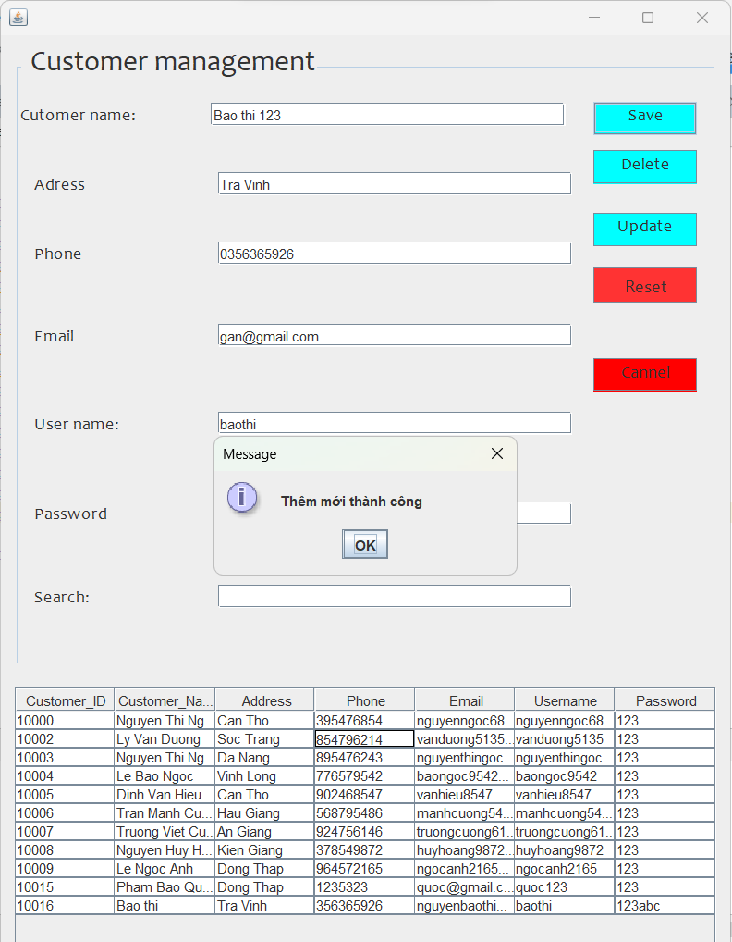

-Click reset to return to the original state.



-In the search box, you can search for full customer information through this box.

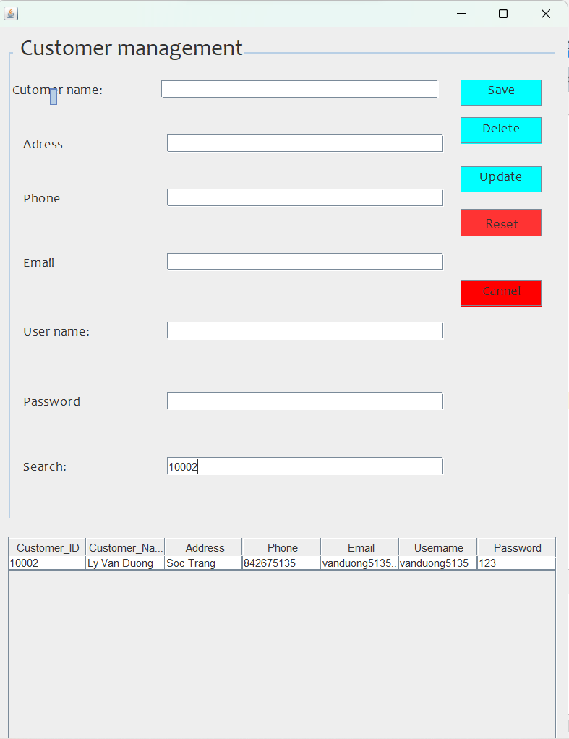

-Click Cancel to return to the Staff page.



-Click Manage Feedback to navigate to the Manage Feedback page.



-Customer feedback will be here. To delete feedback, select the feedback to delete in the dashboard, then click the Delete button.

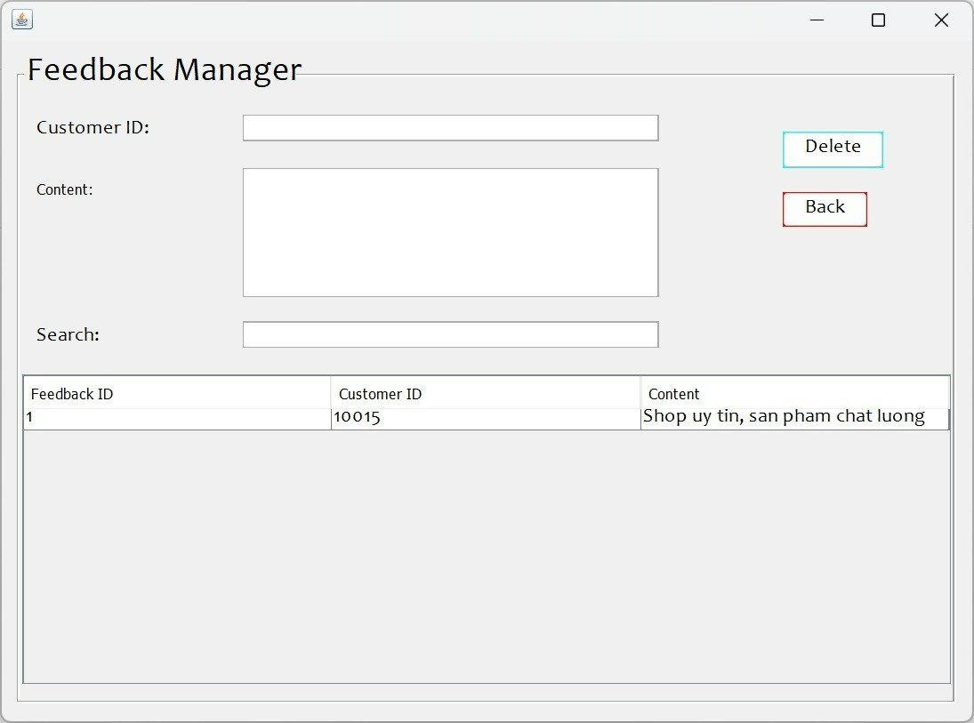

-Then the system will display the message "Delete successful".

-Click the admin button to return to the main interface.



**III. Customer**

-This is the interface for customers to access the app. Click on "CUSTOMER" to proceed to the login form.



- This is the customer's login form, the customer will log in to their account and click Login.

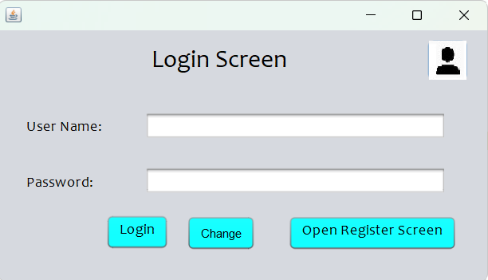

-Click "Change" to change the password.



- Customers enter a new username and password, then click Change to change the password.

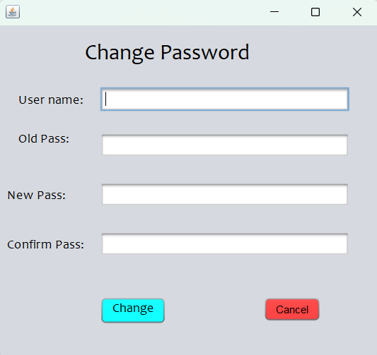

-The system will now notify the customer that the password has been changed. Clicking "OK" will return to the Login form.

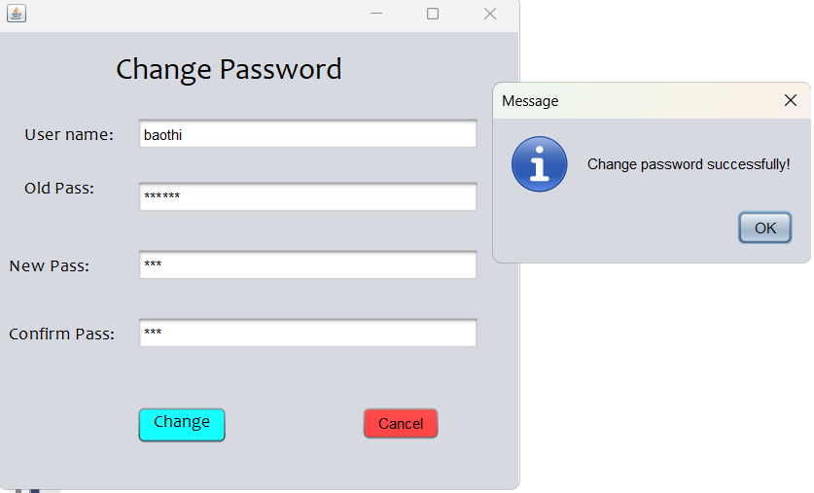

-If the customer does not have an account, then the "Open Register Screen" button will take the customer to the account registration form.



-This is the customer's account registration form. Customers will fill in their information in the form then click Register.

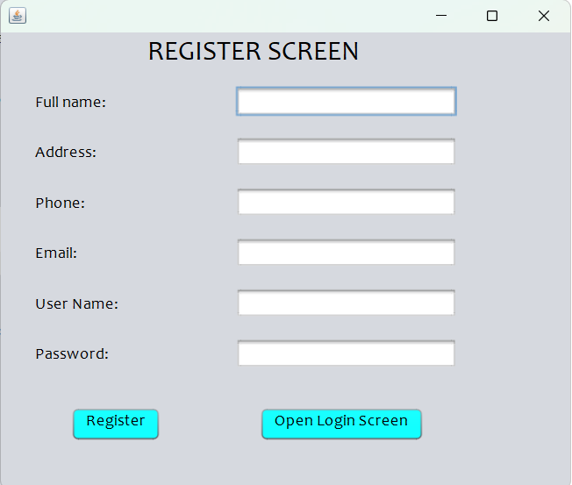

-Then the system will display the message Successful registration.

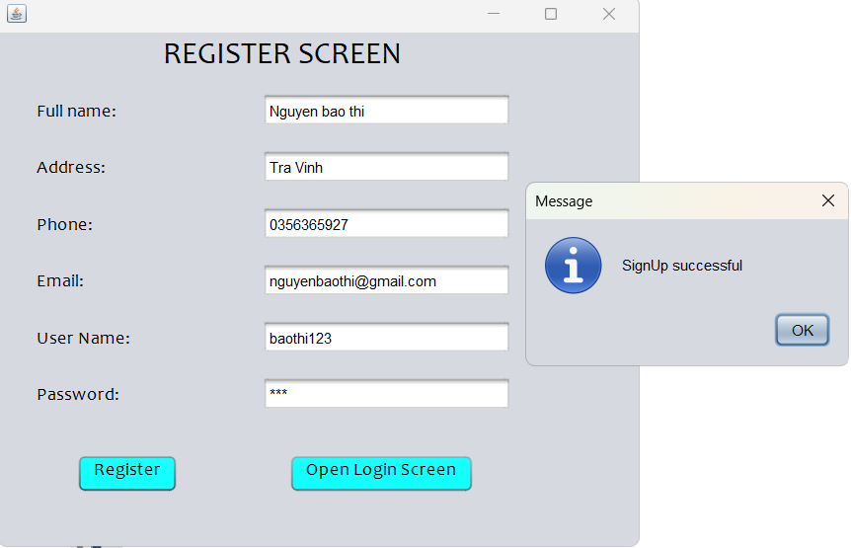

-Click OK, the system will return to the Login page. Customers log in to their account, then click "Login" to login. The system will say "Login successful".

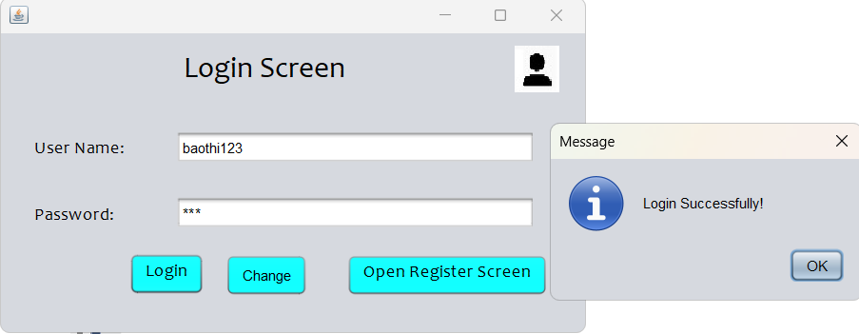

-After successful login, the customer UI will appear.

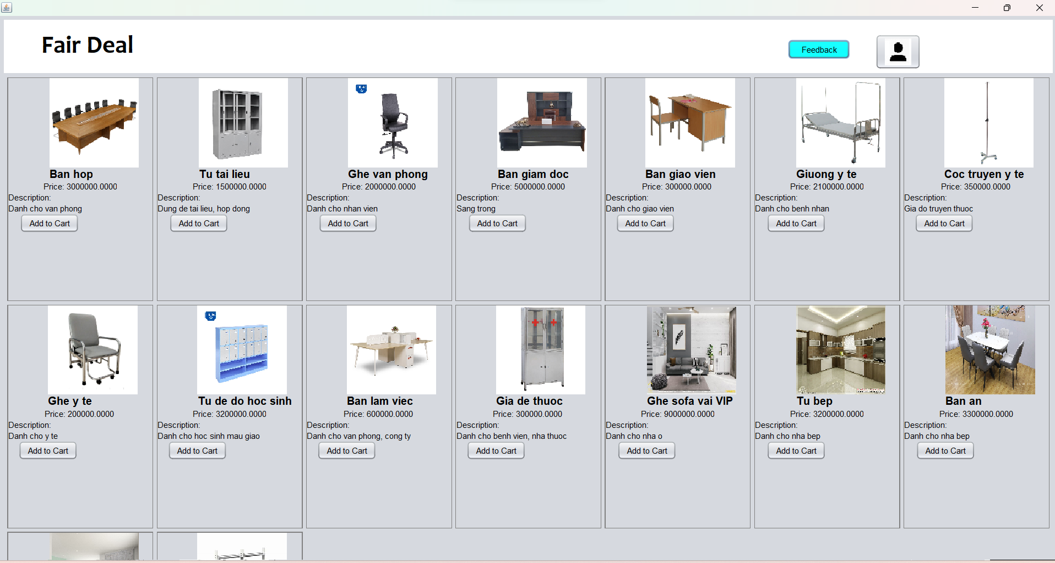

-This is the interface for customers to view and buy products. In this interface, customers will be able to see product details and all products in the store. When the customer clicks on the button, the account will return to the opening page of the app.





-This is a feedback section for customers, when customers click on the feedback button, a feedback form will appear.



-When the customer logs in to the account, the customer's ID will appear in the Customer ID text box. The customer will write his review in the Content box. Once done, the client will have to click SAVE to save the feedback.

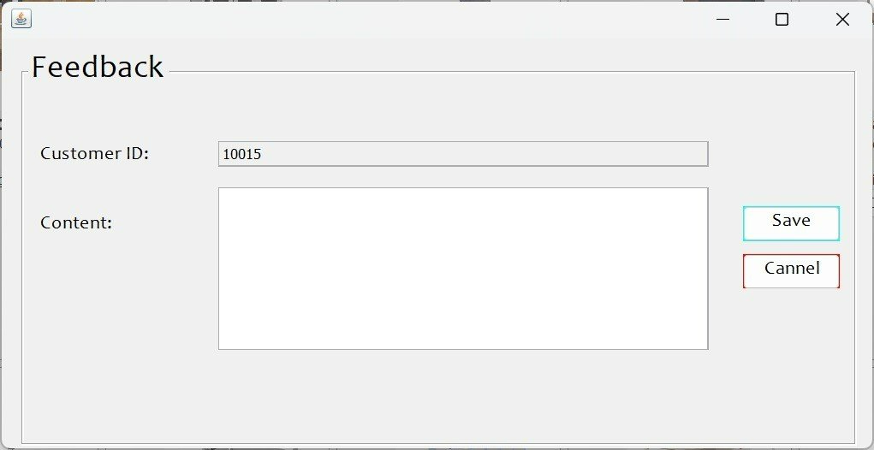

-The system will display a notification letting us know that the feedback has been successfully added.

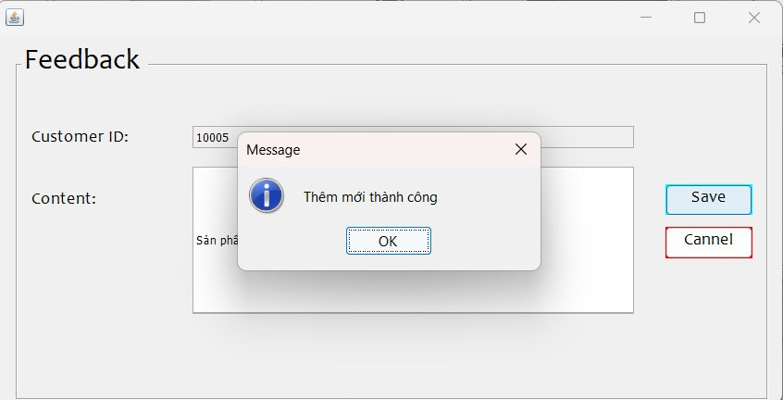

-Click the Cancel button to return to the product UI.



The End.